Tomb of Annihilation

A D&D Adventure

Contents

Contents 1

Additional Characters 6

Rathkran of the Verthisathurgiesh Clan 6

Syndra Silvan 6

Wakanga O’Tamu 6

Eku 7

Xendala 7

Jaheira 8

Montaron 8

Artus Cimber 8

Nanny Pu’pu 9

Locations and Maps 10

Map of Chult 10

Inventory of the Party 11

The Story So Far 12

7/15/2018 12

Day 1 12

7/22/2018 14

Day 1 (cont.) 14

Day 2 15

Day 3 17

Day 4 17

Day 5 18

Day 6 18

Day 7 18

Day 8 18

Day 9 19

Day 10 20

7/29/2018 21

Day 10 (Cont.) 21

Battle 21

Day 11 22

Day 12 23

Day 13 24

8/12/2018 25

Day 13 (Cont.) 25

Day 14 26

Day 15 26

Day 16 27

Day 17 27

Battle 27

Day 18 27

Day 19 27

Day 20 28

8/19/2018 28

Day 20 (cont.) 28

Day 21 28

Day 22 29

Day 23 30

Battle 30

Day 24 31

Day 25 31

Day 26 31

Day 27 31

Day 28 31

Day 29 31

8/26/2018 33

Day 29 (cont.) 33

Battle 33

Day 30 35

Day 31 35

Day 32 35

Day 33 35

Area 1 37

Area 4 37

Area 2 37

Area 3 37

Area 4 (cont.) 37

9/9/2018 38

Day 34 38

Day 35 38

Day 36 38

Battle 38

Day 37 39

Day 38 39

Day 39 40

9/16/2018 40

Day 40 40

Day 41 41

Day 42 42

BATTLE 43

Day 43 43

Day 44 43

Day 45 43

Day 46 44

Day 47 44

9/23/2018 44

Day 46 44

Day 47 45

Day 48 46

Day 49 46

Day 50 46

Day 51 46

9/30/2018 47

Day 51 (cont.) 47

Day 52 47

Day 53 47

Battle 47

Battle 48

Battle 49

10/7/2018 49

Day 54 50

Day 55 50

Day 56 50

Day 57 51

Day 58 51

Day 59 52

Day 60 53

10/14/2018 54

Day 60 (cont.) 54

Day 61 54

Day 62 54

Day 63 54

Day 64 54

Day 65 54

10/19/2018 55

Day 65 (Cont.) 55

A strange situation 55

Battle 56

Battle 57

Back in the real world 57

10/28/2018 57

Day 66 57

Battle 57

Day 67 58

Day 68 59

Battle 59

Day 69 60

11/4/2018 60

Day 69 (cont.) 60

Battle 60

Day 70 61

11/11/2018 61

Day 70 (cont.) 61

Day 71 62

Day 72 62

Day 73 62

Day 74 62

Day 75 62

Day 76 62

Day 77 62

Day 78 62

11/18/2018 65

Day 78 (cont.) 65

Battle 65

Day 79 66

Battle 67

11/25/2018 69

Battle 69

Additional Characters

# Rathkran of the Verthisathurgiesh Clan

I met Rathkran as I walking down the street on my way home. I saw that he was being attacked, so naturally, I jumped in to save him. Once he was safe, I asked him what it was all about. He introduced himself as Rathkran of the Verthisathurgiech Clan. He tells me that he wanted to be a farmer but his parents didn’t agree with him. They grew angry when he ran away to tend to his own farm so they came to attack him. Rathkran said he was grateful for my help and owes me his life. He tells me he will follow me around as a servant.

He has three sheepies that follow him, Eeny, Miny, and Mo. Rathkran loves his sheep. There used to be Meeny, but we don’t talk about Meeny anymore.

# Syndra Silvan

She is an old noble who used to be an adventurer. She has died once on an adventure by taking an arrow to the knee. She has been risen from the dead, and is now affected by the death curse. I know her due to my family owing her a favor. She is seen wearing a mask.

# Wakanga O’Tamu

He is a friend of Syndra Silvan and one of the seven merchant princes.

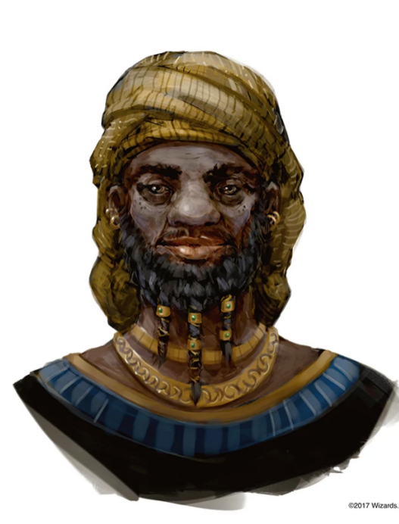

He seems to be very nice.

# Eku

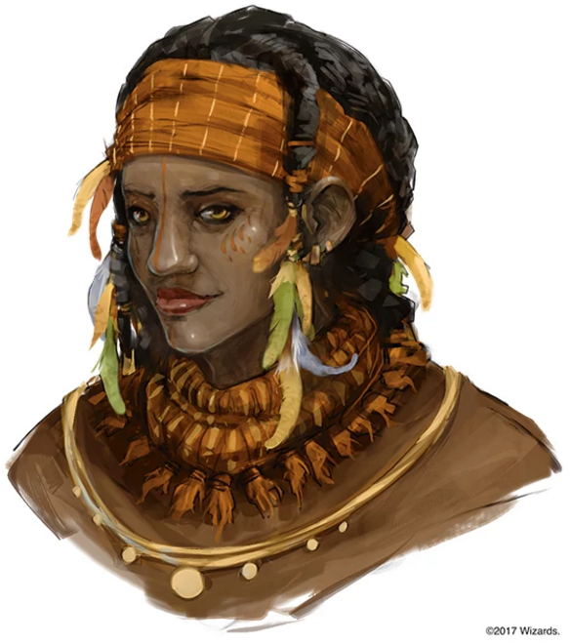

She is a guide. She is going to guide us through the wilderness for a fee of 5 silver per day.

# Xendala

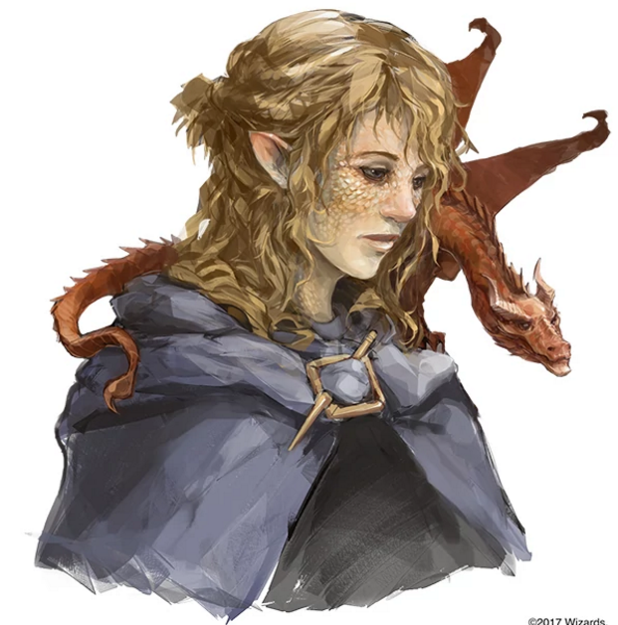

She is looking for her father, whose name is Artus Cimber. She has a pseudodragon friend named Summerwise. We are going to go on a side quest to try and find her father.

# Jaheira

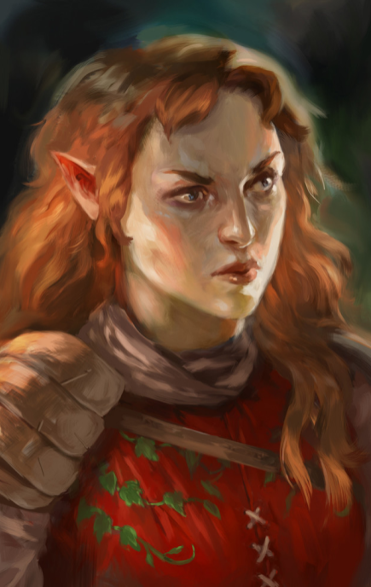

She is an adventurer like us. At this moment, she doesn’t seem like she is very important to us. She was pretty standoffish.

# Montaron

Ilanis seems to know this guy. He is a halfling that is looking to give Ilanis a mission.

# Artus Cimber

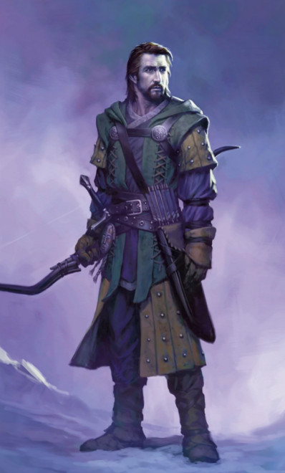

This guy is the dad of one of the other people that I met

# Nanny Pu’pu

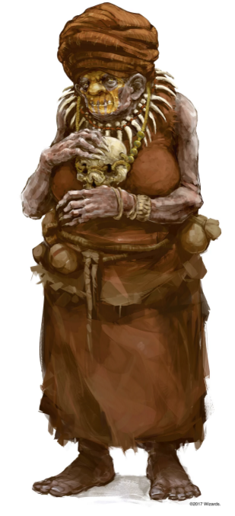 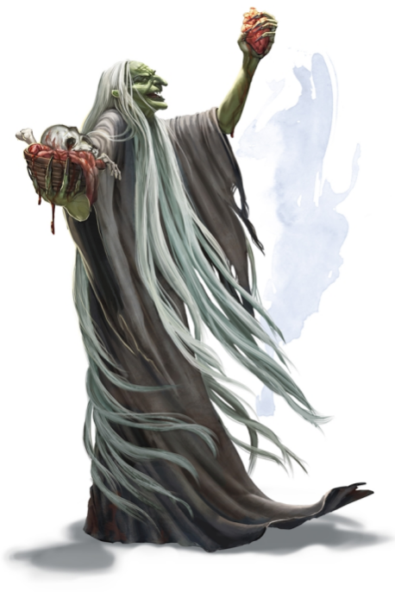

This lady is bad news

Locations and Maps

# Map of Chult

Inventory of the Party

Pouch that has a total of 5 gems. Each gem is worth 10gp

Jug that’s totally not an alchemy jug

Nolzur’s paints (4 jars)

The Story So Far

# 7/15/2018

## Day 1

* There is a death curse that is happening
* Syndra Silvan has invited us to her house
  + Learned about Cindiana Bones, who is an archeologist that has explored the underdark
  + There are fancy nummies here
  + Syndra is planning an expedition to Chult
    - It is almost entirely underway
    - Syndra was an adventurer in the past
    - She has died once and was raised from the dead
    - She has been affected by the death curse
    - She wants us to find a cure or cause of the death curse
    - Harpers know that there is a necromantic artifact called the Soul Monger and that it is somewhere in Chult
    - There is not much know about Chult
    - Syndra has a map that she will give us full of all of her knowledge of Chult in exchange for us going on this mission
    - The climate in Chult is not fantastic
    - Syndra will be taking us to Port Nyanzaru to start off
      * Port Nyanzaru is ruled by 7 merchant princes
    - Looks like the flaming fists are trying to claim land there
      * They are the police force of Baulder’s Gate
      * They started out as mercenaries and then they just kind of evolved
      * Syndra doesn’t quite like these guys
    - This expedition is crucial for everyone
    - If we succeed, Syndra will give each of us a magical item
* At around noon, we head over to Port Nyanzaru via a teleportation circle
  + It’s pretty tropical
  + There is a singing mango
  + Syndra is going to introduce us Wakanga O’Tamu
  + There are dinosaurs pulling a cart with a couple Chultians riding on it
* Wakanga has a lovely house that is lit nicely
  + There are harps that seem to be continuously playing in the house
  + There are guards that don’t seem to wear the normal guard attire
    - Since it is very hot here, they don’t have a whole much on
    - They look very exotic
* As we are walking down the street, it appears that people are staring at us, especially Nekka
  + The crowd seems to disperse as we walk past them
  + Even the guards aren’t a fan of us, but they don’t seem to mind Syndra
* Wakanga seems to have a lot of servants
  + He does not have much information about the death curse
  + He does not have the ability to help us get information because we are untrustworthy
  + Syndra suggests that we go to an Inn/Tavern to start looking around
    - She recommends either the Thundering Lizard or Kiya’s House
  + Syndra says there is also a large bizarre that we can shop in
  + She finally gives us the map which Lunette takes
    - Wakanga doesn’t seem to be a fan of the fact that she is giving this map to us
* We have decided to head to Kiya’s House of Repose
  + On our way we pass a colorful palace
  + We pass by the grand Souk, which is a very busy market
    - There are a lot of guards around us
  + People are still shying away from us as we pass through
* We have arrived at the Red Bazaar on our way to Kiya’s House of Repose
* There are people at Kiya’s
  + There is a Bard playing his lovely music
    - She is a drow
  + There is an elven woman sitting by herself at a table just eating
    - She has a quarterstaff sitting next to her
    - She has red hair
  + There is a middle-aged woman also sitting at a table by herself
    - She has feathers in her hair
  + I order a drink for everyone and ask about any interesting news
    - The bartender doesn’t seem to be a friend of Nakka
    - He tells me about a dragon turtle that has been living in the bay of Chult. It wants a lot of treasure, but he isn’t sure about how much
    - Tells us that a lot of people come to drink because their friends and family can’t be risen from the dead
    - Says it started happening about a month ago
    - There are dinosaur races
  + I talked to the human
    - Her name is Eku and she is a guide
    - Her usual rate is 5 silvers per day
    - She is a bit familiar with the wilderness
    - She is not currently working for anyone
    - She wants to know more about it just like we do
  + We started dancing and having a good time
  + We asked the bartender when and where the dinosaur races took place
    - It happens in the streets of the town and it happens it starts in the red bazaar
* We are off to the races!
* There are a bunch of dinosaurs
  + Big Honker
  + Banana Candy
  + Bone Cruncher
  + Grung Stomper
  + Scarback
  + Nasty Boii
  + Jungle Princess
  + Mountain Thunder
* The Race
  + Scarback is on his last race because he’s getting older
  + Nasty Boii is the favorite to win
  + Big Honker has a winning streak
  + We got to pet some dinosaurs
  + Lunette bet 2 gp on Jungle Princess
  + I bet 2 gp on Nasty Boii
* Two-Legged Race
  + Banana Candy
  + Jungle Princess
  + The winner is…… BANANA CANDY
* Unchained Race
  + Nasty Boii
  + Scarback
  + Big Honker
  + The winner is…… SCARBACK AND NASTY BOII
* We go to the red bazaar and buy some stuff

# 7/22/2018

## Day 1 (cont.)

* We finished our shopping and went back to the in
* We cinnamontographers now
* We talked to the bartender, whose name is Bujune
  + I tried to convince him to lower the price, but he didn’t budge
  + I demanded to talk to his manager
    - This doesn’t end well for me
* There’s a smol Kobold named Deekin
  + He seems like a bard in training
* I felt bad for being mean to Bujune, so I got the most expensive thing and paid him double for it
* Nneka gave Deekin one whole gold for him to play a wonderful tune
  + It’s about the Konkey Donks
  + I tipped him 9 silver
  + Ghost gave Deekin another gold piece and gives him a thumb up
  + Lunette pours Deekin a glass of whiskey and gives him 9 silver
* Ghost walked up to the bard and asked about her relationship with Deekin
  + She says she just met him here about a month ago
  + She thought the idea of a kobold being a bard was interesting
  + Deekin came all the way out to Chult just for an adventurous story
* I asked Stella why she’s here
  + Because of this question, she has an existential crisis
  + She tells me that’s she’s here for the same reason as everyone else
  + I asked if she was excited or scared to go on this adventure
  + She tells me that she’s excited
* I danced for a little while longer
* I told Nneka about me and why I am here, which is because my family wants me to be here
* She tells me that someone at her place of employment is related to Syndra
  + Her pseudomother is good friends with Syndra, which caused her to want to want to go and check on Syndra
* We had some *fun* conversation
* After a while, we all went to bed and have lovely dreams

Day 2

* The night was uneventful, with a light rain greeting us in the morning
* Everyone meets downstairs in the morning
* Ghost orders ALL OF ZE BACON
* Nneka eats an egg whole
  + She can do the snek tongue thing
* The door to the inn opens
  + She’s got blonde hair and a blueish cloak
  + We do not recognize this person
  + She looks very frustrated
  + Stella goes up to talk to her
    - She seems like she’s talking to herself
    - She wants help with something
      * Looking for her father
    - She has a thing (It called her Xendala)
      * It’s Mushu
      * His actual name is Summerwise
    - Her father is a very tall, dark haired human
      * His name is Artus Cimber
* Eku comes in after the frustrated lady
  + She notices the bacon
  + She watches Xendala for a while before asking if we are ready to head out
* Deekin was not here. He was probably sleeping off the alcohol
* The red-haired elf lady seems to be an important person
  + She looks standoffish
  + Kinda tall and kinda beefy
  + She looks like she knows what she’s about
  + She is an adventurer like us
  + Her name is Jaheira
  + She says we look pretty strong
* Eku is familiar with a couple of places
  + Nangalore
    - It’s an ancient place/city with a lot of garden
  + She has helped several people go on pilgrimage to Orolunga
    - She starts to tell us about an artifact which we might be able to ask the Naga ghuardian for guidance
  + She tells us a rumor:
    - The Chultians used to worship the God Ubtai. If we happen to find a maze, it’s recommended that we trace it as we might we rewarded
* We agree that the best place to start is going to be
* As we head out of town, Ilanis hears a whisper
  + She follows the whispers
  + She finds a halfling whose name is Montaron
  + He wants to get back at the leader of the flaming fists
  + Looking for proof of the flaming fists working with the pirates
  + If she’s interested, she can meet Montaron at Fort Beluarian
  + She meets up with everyone else
* Eku recommends putting on the bug spray at the moment
  + She says we are going to be traveling through the woods in the southwest
  + She recommends being especially careful around undead
* For the days of travel:
* *We have paid Eku*
* Eku takes us south, pointing out all sorts of beautiful animals, trees and wildlife
* Morning Encounter:
  + There are giant lizards. Eku says they are quite a sight
  + Ilanis very very carefully walks up to the giant lizard to pet them
  + It sniffs her and she pets its snooooooooottttt
* Afternoon Encounter:
  + We are walking along the trail when all of a sudden THERE IS A DEAD BODY! HECK
  + It is an Elf that looks like it has been bit by a poisonous snake
  + Lunette does a small prayer for him
* Night Encounter:
  + We set up our first campfire!
    - We talk about our parents
  + I told everyone about the fact that I love to fish but I have no idea how to swim
  + Lunette was picked up by the Vestani and whenever she had the chance she ran off to explore
  + Lunette does Tarot readings
    - Nneka’s reading: The trader, 8 of gliphs the Bishop upright, Donjon upright, 3 of gliphs the healer reversed, The Temptor reversed
      * She deals with commerce, both legal and illegal
      * There’s a controlling presence in her life that’s working behind the scenes
      * There’s something to do with imprisonment, isolation of banishment
      * There’s illness, disease or something not fantastic to come
      * There may be some magical forces at work in your life, but there may be a deliberate surrender
    - There is a magical force as this is happening. She can’t tell if it’s something that Lunette is doing, but it’s pretty cool. It’s up to Nneka to determine what everything means
    - My reading: The tax collector, 4 of gliphs the shepphard, 3 of swords the soldier reversed, 6 of coins the beggar reversed, 5 of gliphs the druid upright
      * Trustworthy person of power, even in a corrupt environment.
      * I have devoted followers (Ayyyyyy Rathkran) from my past
      * There is an end to a problem with hard work. There’s no quick victory
      * There will be loss and possible ruin in my future
      * There is going to be a balance of nature and a release of emotions
    - I feel the same presence that Nneka did

## Day 3

* *We have paid Eku*
* There was a rough tropical storm, so we spent the day not traveling

## Day 4

* *We have paid Eku*
* There is light rain today, so we will continue traveling. Eku lead us in the southwest direction
* Morning Encounter:
  + Through the mud there is a chittering noise. There is a person-sized lobster
  + 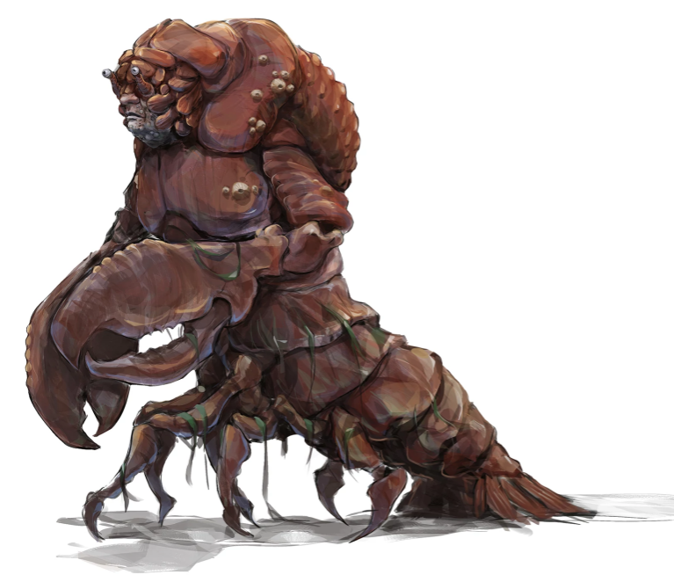
  + Eku tells us that this creature is an Aldani
* Afternoon Encounter:
  + More interesting creatures! This time, we see like, a jungle deer. It yeets past us
  + At first, we think it’s a leopard, but then we see the snek heads
  + 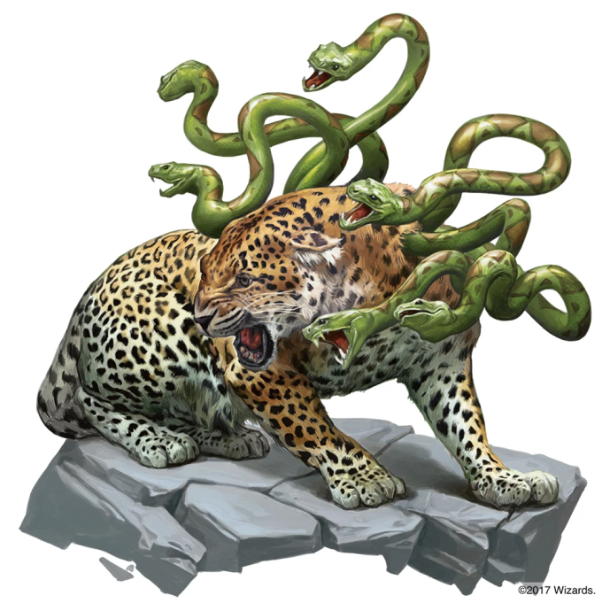
  + We decide to leave it alone
* Night Encounter:
  + We find out that GOHST is from Redwyrm
  + He got recommended for this job. There are benefits for him at home if things are successful for him

## Day 5

* *We have paid Eku*
* There is light rain happening again. Nothing very eventful happens on this day

## Day 6

* *We have paid Eku*
* There is another tropical storm, so we don’t travel

## Day 7

* *We have paid Eku*
* The weather today is a torrential downpour. Some people seem to be starting to run out of food.
* Night Encounter:
  + Eku summons 45 pounds of rations. It can hold us out for about 2-3 days

## Day 8

* *We have paid Eku*
* The weather is once again a torrential downpour once again.
* Morning Encounter:
  + Stella and Lunette feel like the tent seems to be moving around them
  + A hadrosaurs is starting to munch on their tent
  + Lunette handles the hadrosaurs like a fucking champion
  + Nneka disturbs a log. There are 6 horrifying little bat things that fly out of the log
  + 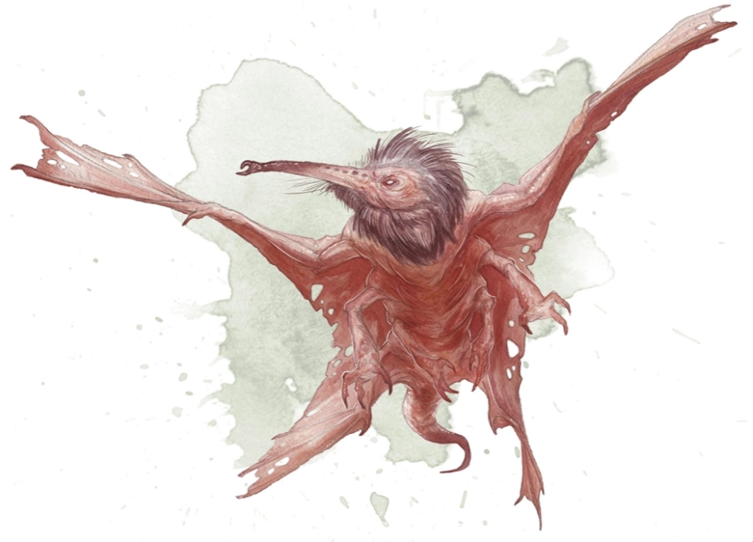
  + Nneka tries to reason with these folks and tries not to scream
  + She does her best to very carefully get off and away from the log
  + Eku does what she can to apologize to the little bat things
    - They are called Stirge
* Nothing of interest happens in the afternoon or the night

## Day 9

* *We have paid Eku*
* It might come as a surprise, but it’s pouring rain again
* Eku tells us there are two places we are going to pass by
* Either Camp Righteous
  + Settlement made by the order of the Gauntlet
  + Would be a place we can probably stay
* The other name of the place is Yellyark
  + This is a place that Eku has passed by but she generally tries to avoid it
  + It’s home to some goblins which is why Eku doesn’t like it
  + She doesn’t know how well the goblins will receive us
* We have decided to go to Camp Righteous
  + Night Encounter:
    - Eku believe we are being followed
    - Stella, Eku and Ilanis are keeping watch
    - 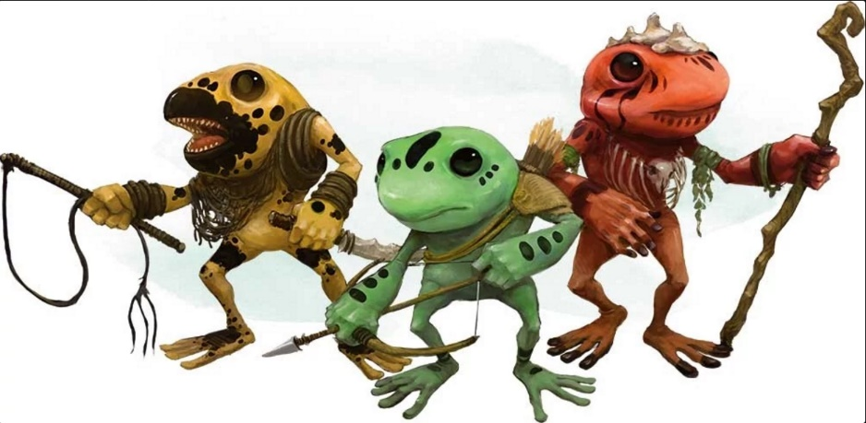They don’t see anything until they are surprised by two frog people who jump out and point their spears
    - Eku is able to reason with the little froggie people and they will let us stay the night

## Day 10

* *We have paid Eku*
* The weather is only a light rain today. Honestly, I don’t think this land knows how to not rain
* We have arrived at Fort Righteous!
* 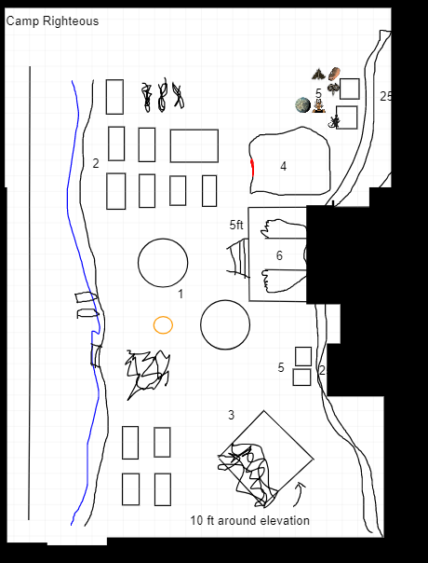
* Everything around Fort Righteous seems to have been ransacked
* Area 2
  + Most of the tents were slashed with claw marks
  + Everything seems to be rotting
  + Eku says it has been a month of two since she was last here
  + There are signs of a struggle here
* Area 5
  + There seem to be two little shacks
  + They smell like super shit
  + There is a dead body here
    - Doesn’t seem to have any stab wounds
    - It is a pit, at least 5ft
    - It died from poop poisoning
    - I have a turd pouch with 5 gems
* Area 1
  + They are abandoned tents
  + Eku tells us the Order of the Gauntlet
  + There are no people inside of here, but there is a single snoot
  + Nneka casts Animal Friendship on it and makes it its friend
  + There are obvious signs of struggle here as well
* Area 3
  + This is a burned-out shrine
  + This is a building and it was definitely on fire at one point
  + There was a pendant in here
* Area 6
  + This is a cave
  + There is a statue here
    - Eku tells us a story about a man who wanted to cross the river. There was a crocodile who spoke to the man asking why he was upset. When the man said he wanted to cross the river, the crocodile offered to bring him across safely in return for a favor. Once they were safely across, the man asked what favor the crocodile wanted. The crocodile wanted to go explore the realm of humans but was afraid of the humans. He wanted to be carried on the man’s back. The man felt as though he had been tricked, but a promise was a promise and he carried the crocodile on his back. The man then swore than the humans and crocodiles would never be friends again.
  + Inside the cave, it seemed a little creepy but otherwise seems like a normal hallway
  + There seems to be some traps here
  + The floor drops out under Stella, but she manages to save herself
    - The gap between us and the other side is 20 ft
    - We come up with a plan to have someone go across with a rope and then hold it to help everyone across
  + There is a second hall that has another set of traps
    - Ghost, despite seeing that we were able to cross with a piggy back, walks through on his own and takes damage
  + There is a puzzle door
    - It’s a checkered pattern
    - I hopped onto Nneka’s shoulders to see if I can see the pattern
    - There were things that were illuminated. I told everyone where to stand
    - Once the pressure plates were set correctly, the lights on the door changed
    - I hopped on Nneka’s back once more and together, we pushed the illuminated buttons
    - The door opened!
  + There was a pillar that had a jug at the top of it
  + It’s totally not an alchemy jug

# 7/29/2018

## Day 10 (Cont.)

* The bushes be rustling
  + It’s goblins

#### ~§~

### Battle

* Eku hits a goblin for 11 damage and kills it
* A goblin hits Nneka for 5 damage
* Stella punches a goblin for a total of 9 damage
* Nneka takes her turn and attempts to hit a goblin but misses. She then uses her bonus action to hide.
* Ghost uses his ice breath to do 9 frost damage to one goblin and 4 to another. The one he did 9 damage to died. After he did that, he action surged to throw a spear at the goblin he did 4 damage to and it does a crit 14 damage to it. Finally, as a bonus action, Ghost uses his off handed weapon to do 5 damage to another goblin.
* Lunette tolls the dead to one of the goblins that took damage but it saved, so he doesn’t take any damage.
* I attempted to use fire bolt on the goblin that Lunette tried to hit, but I missed.
* Eku also attempts to attack the goblin that Lunette and I tried to attack, but she actually succeeded. She did a total of 9 damage and killed the goblin.
* Nneka attempts to take an attack from a bush, but she misses. She goes back to the bush in shame.
* Stella attempts to take out the last goblin, and hits with a total of 5 damage. That 5 damage is enough to kill it.

#### ~§~

* Eku notices that one of the sheepies are missing.
* I’m finna fite
* Nneka and I attempt to look for sheep tracks
  + It appears to have walked off with a bunch of goblins
* Eku knows that the goblin home is in Yellyark

## Day 11

* *We have paid Eku*
* The weather is only a light rain today
* Nothing happens in the morning
* We have made it to Yellyark
* 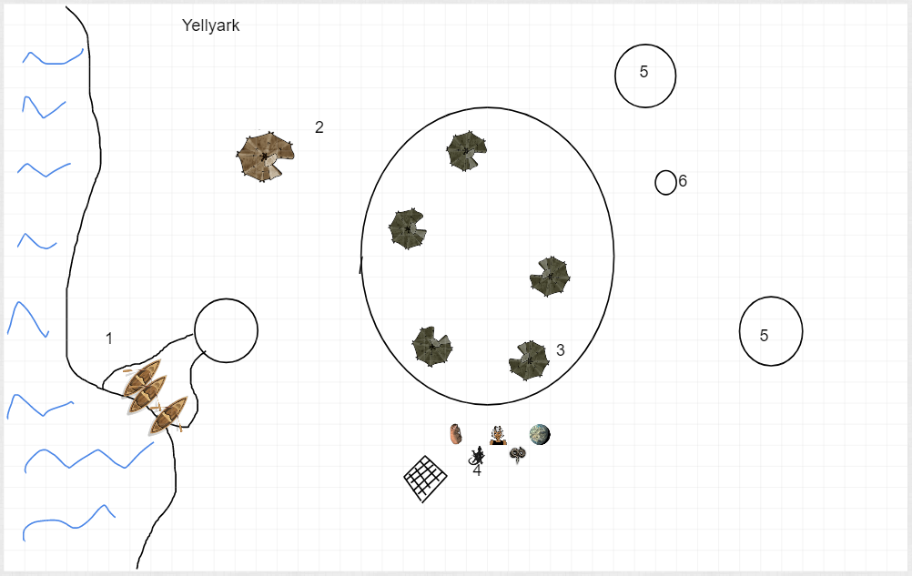
* There is an official looking goblin in the center and there are lesser goblins handing my sheep to him
* 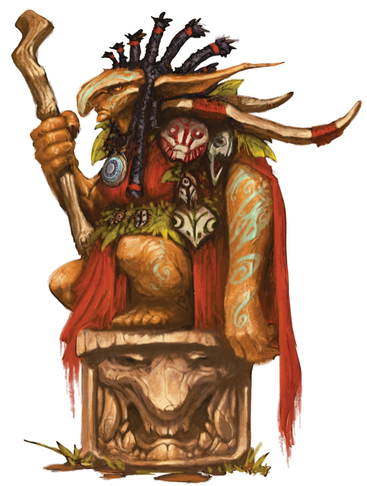
* Ghost is attempting to approach as ready but non-threating as possible
* Nneka is trying to use signs to try to communicate that we want our sheep back
* After a little bit of talking through Eku, we have decided to go and attempt to hunt a dinosaur to try and trade for the sheep back
  + We will have about two days to do this
* Trying to look for tracks but we could not find any
* After going about a mile or two south, I was able to spot a trail of dinosaur footprints
  + Using my knowledge, I could tell that these prints were definitely the guy we were looking to go after
  + All together we were able to follow the tracks of the dinosaur and find it
  + Stella and Ghost were able to take down the tree together
  + Using the tree, we brought the dinosaur to the goblin people
  + They seemed very happy
* Eku mentioned that there are boats that were at Fort Righteous that we should be able to use to travel on water

## Day 12

* *We have paid Eku. I have paid her for a total of two weeks. This means that we won’t have to pay her again until Day 26*
* The weather for today is unsurprisingly a torrential downpour
* I have a strange feeling, like a chill up my spine, but I don’t know the source
* We have made it back to Fort Righteous
* There are boats here that we’re going to use to go in the river
* Syndra’s map is very very valuable
* Night time:
  + Ghost is here because he was volunteered
    - He used to be part of the military
    - He has done a lot of training
    - He used to give a lot of orders
  + We talked a bit about why I’m here
  + Hurray for being not dead
  + Lunette had a skeleton fall on here
    - She was exploring when one fell on her
    - The coolest thing she ever found was a three-sided coin
  + Nneka has a rusty spoon that tastes like meat

## Day 13

* The weather… another torrential downpour. Shocker.
* Eku miraculously remembers the name of the river.
  + It’s the Soshenstar river
* While we are traveling on the river, we find some dead bodies and things
* There is a gate here that Eku doesn’t seem to recognize
* We approach the gate and there is someone on top of it
* After a little bit of back and forth, we determine that this is an Order of the Gauntlet camp
* We are let into the camp and told we should speak to the leader
  + His name is Niles
* 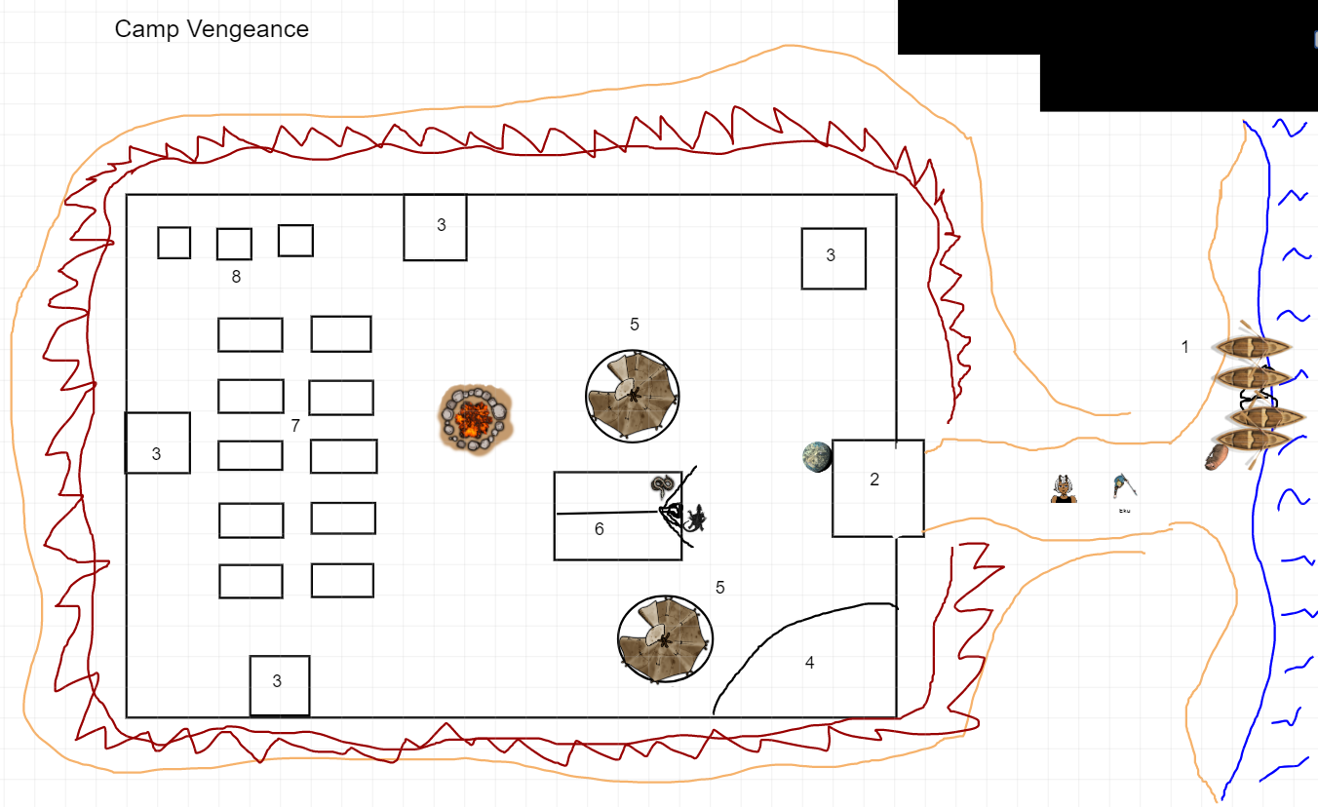
* We are told that this is a camp that was created because Fort Righteous
* People look pretty rough here
* Eku has a friend here that she wants to help (Cleric)
  + Lunette goes and helps Eku, doing cleric things
* Nneka and I have a moment
  + I think it went well :D
* We learn a little more about the death curse
* Plan on investigating by trying to go to the source
* Somehow we negotiate to trade our smaller boats for some bigger ones
  + Lunette points out that we just used their boats to trade them for bigger boats
* Off we go on another adventure

# 8/12/2018

## Day 13 (Cont.)

* We start off… ♪Just around the river bend♪
* We are apparently the “Big swollness”
* We are heading “WeEEeEest”
* He have decided to take the boats and head south
* Nothing happens as we travel ♪Just around the river bend♪
* We have made it to the Aldani Bason
* Eku tells us a tale about the Aldani people as we set up camp for the night
* I asked Neeka if she would teach me how to swim
  + She said yes! (OMG OMG OMG OMG)
  + In return, I want to cook everyone a meal and make Nneka’s extra special
* I look around to try to find something to make good food with
  + I found a dead tree with some shrooms on here
    - These shrooms are not fantastic to eat
    - I tried to pick them up and it was not a very good idea
  + Ghost helped me look for some fish
    - I found one and he caught it for us! Good job, Ghost!
  + I cooked up the food and it was… Not my finest work
* Lunette and I take the first watch
  + There’s a spoopy encounter
  + There appears to be a source
    - Calling the soul monger
  + Uncertain as to who or what is causing it
    - Hypothesis: Litches have velactory
      * Velactories hold the souls of the litch
      * He thinks something like this is what is having an effect on the people around it
      * Basically think there’s a litch involved
    - Heavy concentration in the east
  + Red wizards are divided on some things
    - Thinks curing it can be done by taking the soul monger and studying it
  + Names of the party
    - Dude’s name is Elden
    - Girl’s name is Neera
    - Bigs and Wedge and Lenny are the other not so important lackies
* I woke Nneka and Stella up for their watch
* The rest of the evening passes without an issue

## Day 14

* IT’S A STORM! HOLY SMOKES! WHO. WOULD. HAVE. GUESSED?!?!?!?!?!?!?!!?!?
* We are stuck here for the day
* It looks like Ghost and Elden know each other
* Elden doesn’t look like he didn’t sleep very well
* I added salt to my rations and they tasted better
  + I think my good cooking broke Ilanis, she was too impressed
* Eku and Elden have a stare off
  + Eku nods

## Day 15

* MORE RAIN. I SWEAR, I AM MOVING SOMEWHERE WHERE WATER DOESN’T EVEN EXIST
* Eku is reflecting on Mbala
  + It used to be a village, but it was attacked but supernatural forces
  + They were attacked and Eku was powerless to help them
  + She hopes to visit them on our way back from the Naga
    - We agree to this without fail
* Nighttime
  + I asked Ilanis if she had any special talents
    - She said she has the ability of echo locate
    - She is decent with crafts
    - I heard she’s and absolute THOT
      * This is a lie
    - She really really likes bats
  + Nneka’s favorite animal is a rat
    - I AM GOING TO CATCH HER A RAT!
  + I tried to sneak away to catch a rat
    - I got caught, but I was able to lie
    - I rolled a fucking nat 1 to look for a rat
    - An Aarakocra flies in front of me and offers me a rabbit with a unicorn horn on it
    - 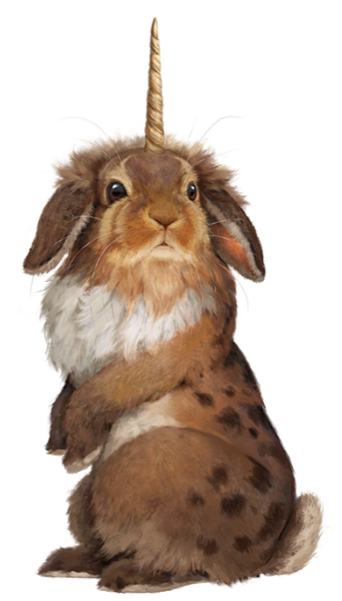 (Almiraj)
    - SHE LIKED IT. OMG OMG OMG SHE LIKED IT! AHHHHHHHH
      * She gave me a peck on the cheek and said it was now her second favorite animal. I am dying, I’m so happy she loves it

## Day 16

* It is only lightly raining right now. Honestly, I will take this over the super massive rain
* Nothing really special happens today

## Day 17

* The weather today is also a light rain
* In the morning, we are approached but 6 Stirge

#### ~§~

### Battle

* One of the Stirges attack Ilanis and attaches to her
* Another Stirge attacks Stella and attaches to her
* Stella pulls the one off of her and kicks it for 4 damage. She then pulls one off of Ilanis and punches it for 4 damage. Both of them are dead
* Two more Stirges attack. One of them attacks Eku and crits her for 9 damage. The other one tried to attack Ilanis but missed
* Eku pulls the stirge off of her and squishes it, doing 14 points of damage to it
* Ilanis started to T-Pose through the fight and so she didn’t get a turn
* Lunette tried to toll the dead on one of them and it worked for a total of 5 damage
* I used magic missile, sending 7 damage to one and 5 points to the last one

#### ~§~

* Nothing really happens in the afternoon
* At night, we are playing cards

## Day 18

* The weather today is also light rain
* In the morning, Eku spots more grung

## Day 19

* The weather today is also light rain
* In the morning, we have been surrounded by light blue mist
  + Eku and Lunette casts bless
  + Everyone but me and Lunette saves
  + Mad Monkey mist
* In the afternoon, nothing happens
* We decided to park the boat
* I feel compelled to touch things constantly
* Poor Lunette is having a panic attack
* I have been tricked into being choked to sleep

## Day 20

* IT’S A TORRENTIAL DOWNPOUR
* This means we aren’t going anywhere

# 8/19/2018

## Day 20 (cont.)

* I pet everything. It’s great
  + Side note, I got to touch Nneka’s tail last night. It was also great
* Poor Lunette isn’t feeling so well, I think she was affected by the mad monkey thing

## Day 21

* Today’s weather is light rain
* Instead of needing to touch everything, I can now no longer speak
* Lunette mentions she thinks she is seeing things
  + I think we are both still mad
* Eku takes pity on us and casts lessor restoration on both of us
* We have made it to our destination
* We start to make our way to the shrine
* There are vines here
  + I tried to cast firebolt to clear them, and they did before reappearing
  + Ghost tried to slash at them, but this also didn’t work
  + Stella tries to climb them, but it doesn’t work
* Nneka and Lunette see something out of the corner of their eyes
  + It’s something small and humanoid
  + 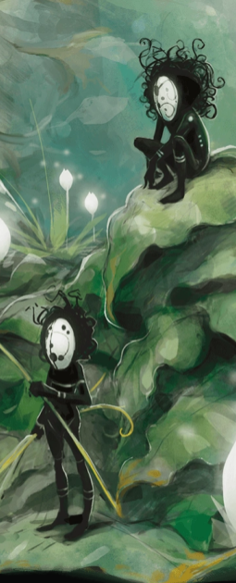
  + It’s carrying something like a purple orchid
  + We decided to find some and start walking towards the vines
  + We are able to do it without an issue
* As we go up a bit further, the ground underneath us starts to crumble and we fall down
  + Ghost sees more of the little dudes and it has a red feather in one hand and an orange and purple orchid in the other
  + We are looking around for more
  + Lunette holds an orchid and some raven feathers and tries to walk up, but nothing happens
  + Nneka and I find a color parrot that’s sitting on a tree branch that leaves feathers for us
  + With that, we all glide up the stairs
* The shrine is on the tier above us
  + There are sneks around us
  + Lunette magically had a muffin appear in her hand while Nneka tried to make friends with the snek
  + She was not able to make friends with the snek
  + There was a little guy that booped the snoot of a snek with the orchid, pet the snek with the feather and then it eats the snek
  + I do the same, followed eventually by everyone else
* In the shrine, there is a snek lady like Nneka
  + There are also two people in this room
    - A rugged looking human man (Artus)
    - A lizard folk with greenish scaly skin (Dragon bate)
  + Mezro
  + Artus Cimber
* Saja N'baza is the snek lady
  + She wants to know what we want here
  + We tell her that we want to know about the death curse
    - She tells us something we already know, which is that this is a curse that has an effect on the dead
    - She doesn’t know the cause
    - There are omens that point to the lost city of omu
      * It used to exist in the South
    - We somehow ended up in a pocket dimension
    - Omu was once a great city
      * There are two remnants of Omu
        + A jungle of which beyond that is a garden

Eku thinks this is Nengalore

* + - * + The other is somewhere in the sky

Guarded by the people of the sky

* + Ras Nsi
    - Something important
    - Something that is a menace and that must be dealt with
    - He must be stopped
    - Located in Omu

## Day 22

* It is downpouring today
* Everything seems to get put to normal as we are looking to head off
* Mbala is definitely the first place we are heading to
* ♪Back around the river bend♪
* There was nothing eventful that happened
* During the night time we talk about party names
* Party name ideas
  + Monstars
    - Rejected
  + Pirate Negotiators
  + The Negotiators
  + Tasty Negotiators
  + The Monstar Negotiators
  + **Association of Negotiation**
* WE ARE THE ASSOCIATION OF NEGOTIATION!!!

## Day 23

* It is downpouring today… again…
* We decide to move at a bit of a quicker pace today
* In the afternoon, there are giant toads in the way
  + We don’t provoke them
* At night, we are ambushed by GRUNG

#### ~§~

### Battle

* One grung is going to attack Stella. They are going to hit for 6 points of piercing damage.
* 2nd grung is going to attack Nneka. They are going to his for 5 points of piercing damage.
* 3rd grung is going to attack Nneka. They are going to miss!
* 4th grung is going to attack Lunette. They are going to CRIT for 6 points of piercing damage.
* 5th grung is going to attack Stella. They are going to hit for 3 points of piercing damage.
* 6th grung is going to attack me. They are going to hit for 3 piercing and 6 points of poison damage.
* 7th grung is going to attack Stella. They are going to hit for 8 points of piercing damage. She punches the guys next to her for 4 points of damage before falling unconscious.
* Lunette used healing word to heal Stella for 12 points of healing. She then tolls the dead on one of them but it fails
* Ghost uses his breath weapon to 3 damage to two of the grung. He then uses his action sirge to throw a spear at one of the grung and CRITS for 9 damage. Finally, he uses his bonus action to use his Symitar to try and hit one but is misses
* I used scorching ray to hit three different grung. I did 4 points of damage to two of them and CRIT with 14 points of damage
* Out of all of the grung that attacked, only one of them his Nneka for three points of damage
* Ilanis turns into a dire wolf and swipes her paw at one of the grung in front of Stella. She hits for 13 points of damage
* One grung is going to attack me. It hits for 3 piercing and 8 points of poison damage.
* Eku is going to attack the grung in front of me. She CRITS for 17 damage.
* Nneka heals me for 6 points of healing.
* Stella is going to attack the grung in front of her. She hits for a total of 7 damage. She then moves to attack another grung for a total of 9 damage.
* Lunette tolls the dead on the grung in front of her. He fails and so therefore takes 7 points of psychic damage.
* Ghost attacks and misses one but hits another attack, hitting them for 4 damage.
* I used magic missile, sending one to the one in front of me for 4 points of damage and then sending two to the one in front of Lunette, hitting them for 7 points of damage.
* Grungs try to attack Stella, but nothing seems to hit.
* Ilanis attacks with her big ol wolfy paw and boops them for 11 points of damage and kills it
* Eku attacks the other grung that was in front of Stella and boops it for 13 poitns of damage and kills it
* The last grung tries to run so Ghost rips the spear out of him.

#### ~§~

* We all decided to pet Ilanis!

## Day 24

* There is a tropical storm

## Day 25

* We are just looking at a light rain today
* We see nessy in the afternoon

## Day 26

* Tropical storm again… This means we aren’t going anywhere…
* We need to pay Eku again, so I have paid her 6 gold and Lunette paid her 1 gold
  + She is paid for until day 40
  + I gave her an extra 3 gold just for being awesome and because I appreciate everything she does for us

## Day 27

* Tropical storm again… This means we aren’t going anywhere…

## Day 28

* Tropical storm again… This means we aren’t going anywhere…

## Day 29

* FINALLY WE CAN MOVE… It’s a light rain today
* We have made it to Mbala
* It’s on a pretty high cliff
  + I start climbing and so does another couple of people
  + There is actually a path, so we take that instead
* It’s got its own perils, but there is no immediate dangers so it’s easy for us to climb
* There is a massive chunk of earth and rock with a spoopy tree on top
  + Eku says this is the heart of Ubtao
  + It’s common amongst Chultians to talk about it because it looks like a literal heart.
* There is a lot of ruin in Mbala
  + Eku seems sad and hurt by this
  + In order to attempt to make things right, we are looking to move the skulls and investigate
  + There is one lone structure still intact about 1000 ft from the gate
  + Lunette knows that there are totems that warship orcus
  + When we go into the hut there is an old human woman that runs out of the hut
  + 
  + Nanny Pu’pu is her name
  + She tells us that the people of the village were killed by winged folks
  + She wasn’t taken because she was too old
  + I used to suggestion to suggest that Nanny Pu’pu tell the truth
    - She failed the wisdom saving throw
  + After a while, she turned into this:
  + 
  + She tells us that the rest of the village was gullible
  + Nneka throws a dagger at her face which hits for 6 damage
  + There is a giant fist or two that punch up from out of under the ground
    - This comes up from the ground:
    - 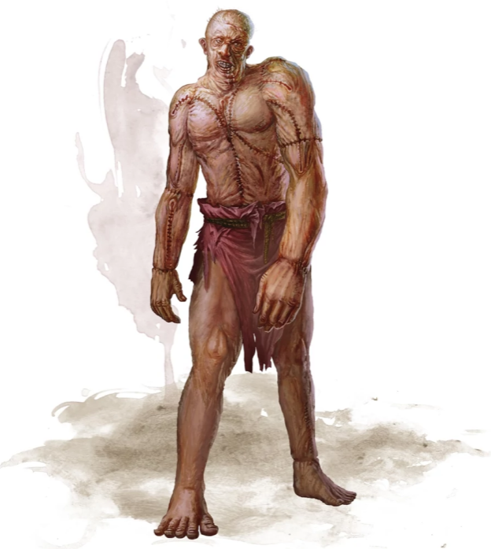
  + We finna fite

# 8/26/2018

## Day 29 (cont.)

#### ~§~

### Battle

* Stella makes an attack against Nanny Pu’pu. She does a total of 4 damage. She then spends a key point to do fury of blows, but both attacks miss.
* Eku casts sanctuary on me. She then casts bless on me, Stella and Nneka
* I used Chromatic Orb on the Flash Golem to do fire damage. I hit with 15 points of fire damage
* Nneka used bane to cripple Nanny Pu’pu and the Flesh Golem. They both failed their saving throws so now they need to roll 1d4 and subtract that from their total. She then uses her bonus action to try and sneak around
* Nanny Pu’pu takes aim at Eku and hits with 7 points of poison damage. Eku has become poisoned
* Ghost emits a low growl and his eyes glow. He flips his scimitar and casts Chill Touch. He hits with 5 points of damage. With is bonus action, he makes an attack and CRITS for 7 points of piercing damage.
* Lunette is about to burn a mf. She uses Burning Hands to burn the Flesh Golem. He fails his saving throw thanks to Nneka’s Bane and takes 8 points of fire damage.
* The Flesh Golem attempts to attack Ghost and then Lunette, but both attacks miss. What a scrub
* Stella uses Radiant Sunbolt against the Flesh Golem and hits with 4 points of damage.
* Eku makes an attack at seemingly nothing. She does not hit.
* I used Chromatic Orb again and hit the Flesh Golem for 9 points of fire damage.
* Nneka looks in the direction where Eku swung and casts Faerie Fire. Nanny Pu’pu failed her saving throw. Bane is no longer in effect
* Nanny Pu’pu is going to try and attack Eku but misses horribly. She attempts to run away which gives both Nneka and Eku an attack of opportunity. Eku misses but Nneka was able to shank her with 9 points of piercing damage.
* Ghost runs over to Nanny Pu’pu, taking an attack of opportunity from the Golem but the Golem misses. He swings to attack Nanny Pu’pu a couple of times, but only one hits her. He does 8 points of damage to her. He also backhands me. Rude.
* Lunette uses Inflict Wounds on the Flesh Golem and does 21 points of necrotic damage.
* The Flesh Golem hits Lunette for 19 bludgeoning damages.
* Stella hits Nanny Pu’pu for 8 points of damage. She then punches again for a total of 4 points of damage.
* Eku bonks the Flesh Golem for 9 points of bonking damage.
* I used Chromatic Orb to do 23 points of fire damage. I yell at the Flesh Golem and kinda flail when I throw the fire and say “DON’T HURT MY FRIENDS” and kill the Flesh Golem.
* Nneka does a sneak attack and does 10 points of piercing damage. She then inspires Ghost.
* Nanny Pu’pu is going to reach out to Stella and do strange Nanny Pu’pu things. Stella saves so nothing happens.
* Ghost swings to make an attack and misses the first one, then hits two times. He then swings a couple more times and misses those as well. He does a total of 13 damage.
* Lunette needs to heal herself, so she casts Healing Word. Lunette is feeling pretty drained after that last attack. Ghost needs to make a constitution saving throw against Lunettes spell save DC and he doesn’t make it. Instead of just healing herself, she takes the health from Ghost, dealing 8 points of necrotic damage and healing that. She then casts Word of Radiance on Nanny Pu’pu and does 1 point of damage. Ghost loses 4 hit points permanently
* Stella is gonna punch. She does 4 points of punching damage. Then, as a bonus action, she punches again for an additional 2 points of damage.
* Eku looks questioningly at Lunette. She moves towards Ghost and heals him for 11 hit points.
* I used Firebolt on Nanny Pu’pu and hit for 8 points of fire damage.
* Nneka does a sneak attack and does 11 points of piercing damage. She stabs it super-duper amounts of times and then at the end cuts Nanny Pu’pu’s head off.

#### ~§~

* We all have some questions for Lunette
* Lunette says some prayers and then I burn everything
* Lunette finds that there is a well near us
  + We go near it and look inside of it
  + Lunette uses the light cantrip on a rock throws it down
  + There is a lot of water in the well
  + Nneka is having a rope tied around her and she’s going to go down the well
  + Nneka is able to feel around and find a sack with a bunch of stuff in it, the least of which is gems
  + We find the following in the sack:
    - 6 onyx gems
    - A spell scroll of Comprehend Languages
    - 10 adamantine ingots
* I checked on Eku to make sure she was alright
  + She said she was alright
  + She is happy that we stopped here for her
* We decide to go to the heart of Ubtao next then make our way back to Port Nyanzaru
* Nothing else eventful happens for the day

## Day 30

* THERE IS NO RAIN TODAY. It’s a miracle
* I get very excited and bounce up and down
  + As I do that, there is a giant frog
  + Nothing exciting happens
* We make it to the shore by night fall
* This place is pretty sketch
* I STARTED TO LEARN HOW TO SWIM!
  + I rolled very well on my Athletics check and was able to start learning how to swim
* Ghost calls out to Stella after walking a bit away and asks if she wants to play catch
  + He throws a SPEAR at her but misses
  + It disappears and then reappears in his hands. He throws it again and this time it looks like it’s going to hit her
  + She catches it and throws it back at Ghost

## Day 31

* It is a torrential downpour again. The sun was good while it lasted
* Nothing really happened in the morning or afternoon
* According to Eku, the heart of Ubtao is very sacred to the people who warship Ubtao, which is most Chultians
* She has not been inside of it before
* We start to set up camp
* I take an hour to cast Find Familiar to summon a rat
  + I take it to Nneka and show him off
  + His name is Remy
* Nearby there is an Ankylosaurs

## Day 32

* There is a light rain for today
* Nothing of significance really happens for the entire day
* Lunette is going to do a reading for Stella
  + Stella’s reading: The Monk, Donjon upside down, The druid upright (five of glyphs), the solder (three of swords), the raven upright
    - Past – True freedom
    - Present – There is a balance of nature and a release of emotions
    - Future – There is an end to the problem with hard work
    - Outcome – A potential ally or important information will arrive. The outcome will be good.

## Day 33

* There is a torrential downpour today
* 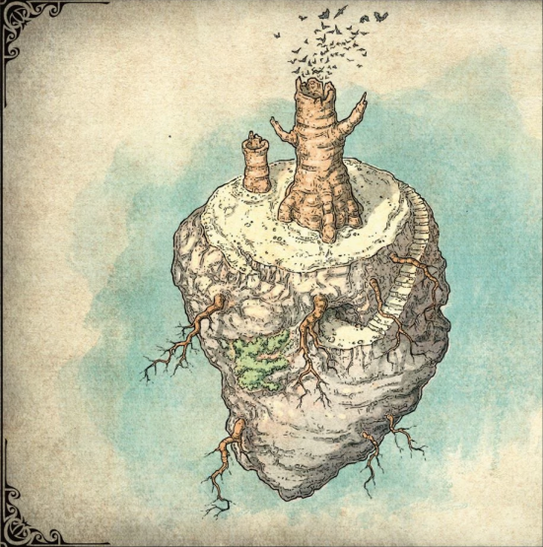
* There is a strange red liquid
  + I drank it because I can
* Up on the top of the heart of Ubtao:
* 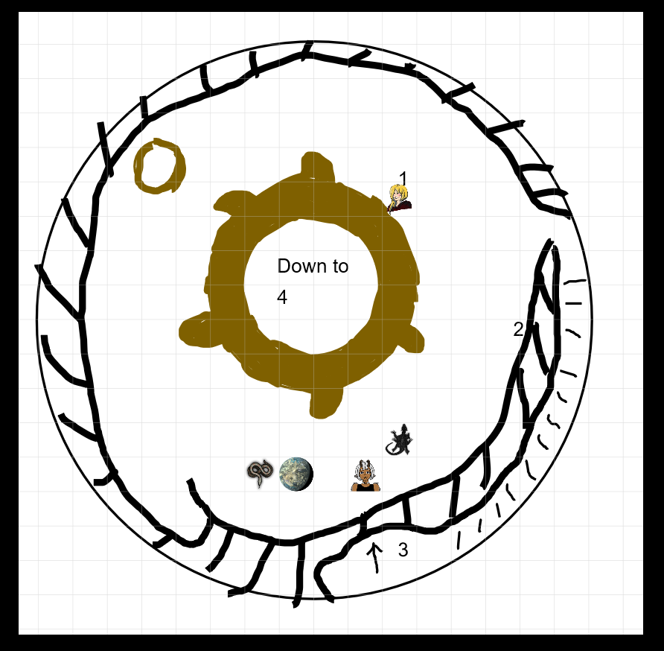

### Area 1

* The petrified tree
* Lunette knocks on the tree and more bats come out
* It’s definitely hollow
* I sent Remy in

### Area 4

* Remy sees some torch lights inside and hears some footsteps

### Area 2

* These are just stairs that lead down to the cave (Area 3)

### Area 3

* A cave entrance
* There is a person here
  + Her name is Valindra
  + She seems to know Lunette
  + Ghost seems to know her
  + Eku is just looking at everyone
* I asked Valindra why she was here
  + She told us she was searching for the soul monger
* 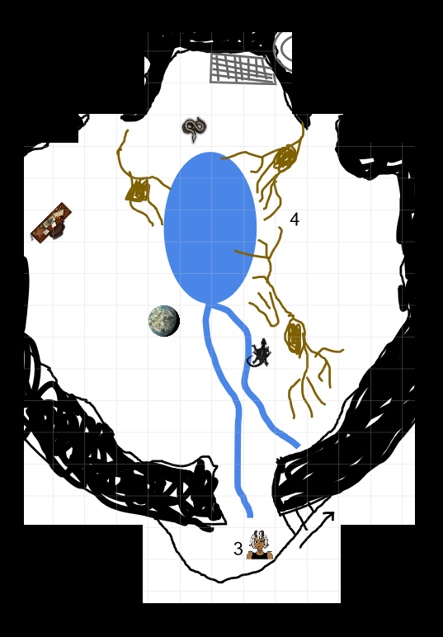

### Area 4 (cont.)

* Valindra kinda knows about Lunette’s parents
* Valindra was there when Orcus came to Fay
* Orcus is actually Lunette’s father
* Valindra talks about Omu
  + She’s trying to scry for Omu but isn’t having any luck
  + She said she doesn’t really care what’s in Omu except for the soul monger
* I DO NOT LIKE VALINDRA (insert angry face)
* I attempted to cast Suggestion to get Valindra to tell us everything
  + It didn’t work so well for me
  + There was a flash of a skull with glowing eyes
  + I was the only one to see it
  + I was spooked but not frightened
* Everyone else seems to want to make an agreement with Valindra
* She has been trying to scry for Omu but it has not been successful
* We appear to be staying the night here in the heart of Ubtao
* Before I go to bed, I walk up to a book case and just touch it
  + She does the spooky thing from before, but this time it frightens me
  + I walk away slowly and then run to Nneka
* We all go to sleep

# 9/9/2018

## Day 34

* This might come as a surprise, but it’s raining (men)
* Nothing of interest happens in the morning or afternoon
* In the evening, we are setting up camp when suddenly, there is a giant snake
  + Nneka makes friends with it

## Day 35

* There is just a light rain today
* Nothing of interest happens today, but everything looks ominous
  + The trees look gross and everything smells

## Day 36

* It’s raining again today
* There are some really gross smells
  + It smells like dead bodies

#### ~§~

### Battle

* Eku is going to move and attack one of the Zombies. She is going to crit it for 9 points of damage
* One of the Zombies are going to attack Nneka, but they miss
* Another one moves and attacks Stella. Stella takes 6 points of damage and resists the poison
* Ghost attempts to make an attack on one of the Zombies and hits for 15 points of damage
* Nneka uses fairy fire and makes a couple of Zombies sparkly
* At some point I was hit by a Zombie and it did 7 points of damage to me and paralyzed me
* Another Zombie hits me and crits me for 23 points of damage
* Ilanis did 11 points of damage
* Stella goes to make a move but a Zombie makes an attack of opportunity and crits he for 14 damage
* A Zombie makes an attack against Ilanis and misses like a loser
* I rolled a death saving throw and passes
* Eku heals me for 6 points
* A Zombie tried to nom on Stella but they suck and miss
* Ghost picks Stella up. He then throws an ice knife at a guy and does 7 damage to two of them. He then uses an action serge to use ice breath on them for another
  + “This bitch empty, yeet”
* One of the Zombies attacks Ghost and does 7 points of damage
* There is a second Zombie that is going to attack Stella.
* Nneka heals Stella for 8 points of healing with bonus action healing word. She then makes a snek attack against one of the Zombies for 9 points of damage
  + “The healing word is ‘fuck’”
* A Zombie attempts to nom me but is an idiot and munches his own finger
* Ilanis puppy tried to make an attack and but missed
* Stella gets down off of Ghost and moves to punch the Zombie that’s standing above me for a total of 3 points of damage. She then
* There is a Zombie that tried to attack someone but they misses
* I used scorching ray and did 15 points of damage to one of them
* Eku attempts to attack the one that I attacked but missed
* Two Zombies try to attack Ghost but he has insulted them so they both miss
* Ghost throws an Ice Knife at one of them and does a bunch of damage. He finally took one of them down.
* A Zombie hits Nneka and does 9 points of slashing damage.
* Nneka doesn’t take so kindly to the attack and stabs him to more death.
* The Zombie attempts to attack Eku but misses like a scrub
* Ilanis bites the thing for 10 points of damage
* Stella is going to whack-a-bitch with a staff and hits for a total of 7 damage
* A Zombie hits Ilanis for 8 points of damage
* The rest of the battle goes without a problem

#### ~§~

## Day 37

* There is rain going on
* There is nothing that happen in the morning
* In the afternoon, we find a dead body pinned to a tree
  + In the pocket of the dead body, there is a tube
  + There is something in the tube
  + There are just some gems
* Nothing else happens at night

## Day 38

* It’s raining again today
* The morning is quiet
* In the afternoon, we approach a big thorny wall
* I sent Remy in to investigate, but after a while, he gets destroyed
* We go in and investigate the maze
  + After a long time we finally make it
* There is a king who is trying to gain the affection of a lady named Nangnang
* I asked the king if he happened to know anything about Omu
  + He said that he had heard about it, but he had not been there
  + He doesn’t know where it is
  + He says he knows that there was a queen there that was exiled
  + She made a deal with a fowl demon and her people would not be able to forgive her
* There is a girl named Krr’ook that says that if we go forward without ceremony things will not end well

## Day 39

* The weather today is BEAUTIFUL
  + Nneka teaches me more on swimming
* At night, there is an arena fight so that Groak can try and win NangNang’s affection
* Artisimber and Dragonbate need to fight each other
* After a while, Ilanis makes some lily pads bloom
* I make the cardboard cutout float with mage hand
* We make this thing look as real as possible
* Nneka is able to use her words to deceive the king
* We have received the prisoners
* Krr’ook said that we can have the paints as well as a ring of jumping

# 9/16/2018

## Day 40

* Weather: clear and sunny
* Morning:
  + Nneka suns herself on a rock, Ilanis is displeased
  + Heading towards Port Nyanzaru
  + Nothing else happens
* Afternoon:
  + Nothing happens
* Night:
  + As we’re setting camp, catch scent of death on the wind and loud footsteps
  + Ilanis: “You have a snake butt.”
  + Nneka: “I mean, yes, I do.”
* Perception check: Something is coming this way from the south
  + Also Artus and Dragonbait are here
* Nneka climbs a tree to hide and scoops Lunette up into the tree with her tail.
* Everyone else does too, Ilanis turns into a bat and perches somewhere
* 4 Large Zamboes with grey rotten skin with large weapons approach, don’t notice us.

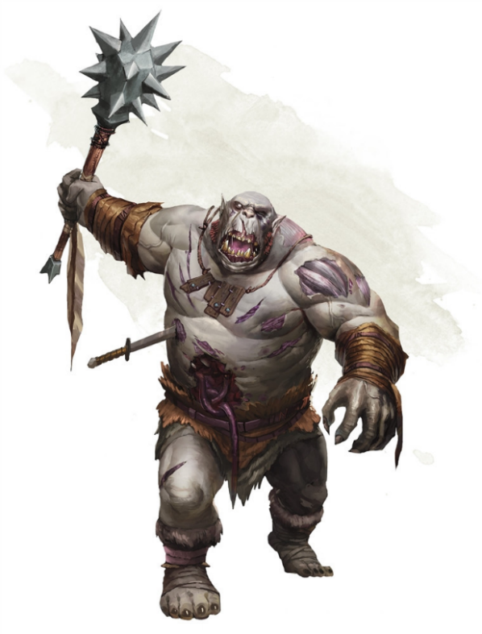

* Lunette thinks she’s got this, but she don’t got this, Turn Undead doesn’t work because she’s in the Raven Queen’s time-out corner.
  + Also Ilanis now knows Lunette is the daughter of Orcus
* Ilanis: “What the #ActualFuck”
* PARTY VOTE: Attack the zombies?
  + Outcome: Nah
* We decide to sleep in the trees tonight

## Day 41

* Weather: Raining
* Morning:
* Ilanis: “OH FUCK” *falls out of tree*
* Also we remember Artus Cimber and Dragonbait are there.
* No one’s discovered anything new since we last met
* Artus and Dragonbait want to avoid the port so we part ways (Lots of people are looking for him because of something he did?????)
* Mentions Harper pendant again, says to be careful who you wave it around at
* Find a large plant that’s person-sized with 3 multicolored flowers

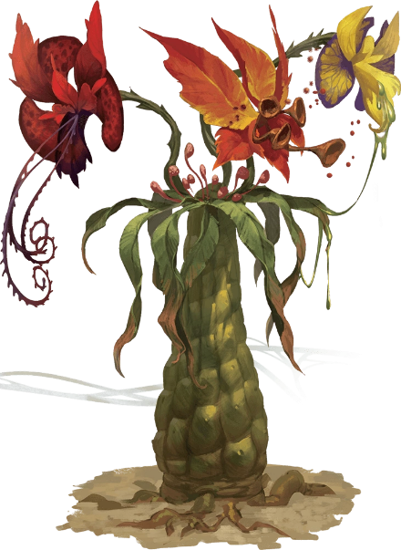

* Ekku doesn’t know what it is
* Seems to move in the breeze but there’s no wind
* Ghost throws his spear at it, rolls a 1, hits Ilanis
* Ilanis takes 6 piercing damage, Ilanis is not pleased
* We decide to leave the flower alone, Ilanis bonks Ghost on the head with a stick
* Afternoon:
  + Nothing happens
* Night:
  + Nothing happens

## Day 42

* Weather: Torrential downpour
* Morning: Nothing happens
* Afternoon: Nothing happens
* Night:
  + More smell of death, more shambling, not as loud as last guys, monkey noises??
  + Ilanis doesn’t wanna sleep in a tree again.
* Ghost hides to ambush, Nneka hides in a bush, Ilanis makes sure she isn’t in spear range
* STEALTH CHECK: 9, 21, 18, 26
* We see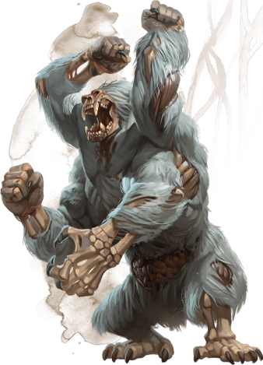
* Everyone: WHAT THE SHIT
* Nneka’s icon gets changed because oh god why
* DM: WAIT, THE DICK IS THE MONSTER

(gwyn pays Ekku for next 2 weeks)

#### ~§~

### BATTLE

* SURPRISE ROUND FOR US:
* Nneka: Throws dagger, hits for 14 piercing, Bonus Action: Hides
* Ekku: Casts Bless on Lunette, Nneka, and Ilanis
* Ilanis: Turns into Direwolf(bigger boof), moves in and CHOMPS for 8 piercing and knocks zombie monkey prone
* Lunette: Casts something?? And monkey zombie just stands there. Tells it to fuck off and IT DOES
* VICTORY…?
* Everyone: ????????????????????

#### ~§~

* Lunette says she cast Turn Undead, no one’s super convinced.
* Ghost does Arcana check, it was turn undead kind of
* Nneka does Insight check, knows lunette isn’t telling the whole truth.
* Lunette: “I just called on the power of my god.”
* Nneka: “WHICH god?”
* Lunette: “Uhhhhhhhhhhh”
* Ekku gives Lunette a pep talk about not giving into Orcus’ temptation
* We schleeeeb

## Day 43

* Weather: A beautiful sunny day
* Morning:
  + Suddenly 4 giant lizards sunning themselves on rocks
  + Nneka joins the sunning lizards, it feels GREAT
* Afternoon: Nothing happens
* Night: Nothing happens

## Day 44

* Weather: Tropical Storm
* Lunette prays and meditates all day, and her tent smells of incense

## Day 45

* Weather: It’s raining men
* Morning: Nothing
* Afternoon: Really boring
* Night: Nothing

## Day 46

* Weather: It’s still raining
* We decide to walk double fast to get to port faster
* NOTHING HAPPENS

## Day 47

* Morning: nothing
* Afternoon: We make it Port Nyanzaru
  + We arrive in the slums, everything seems built on of each other with rickety bridges connecting stuff.
* We go to the bathhouse because THANK GOD CIVILZATION
* Head to public bathhouse that is sponsored by Pelor’s followers
  + -“Both egalitarian and elegant”
* Gwyn gets to Nneka naked and vice versa
* Nneka has seen a lot of naked people in her time so it doesn’t faze her
* Ilanis is blind
* Nneka immediately forks over the gold as soon as someone says “massage”
  + Ilanis: “Hey Ghost”
  + Ghost: “what”
  + Ilanis: “*Cloaca*”
  + Ghost freezes Ilanis’ hand to the floor
* We’re nice and clean now
* To sell our jewels we gotta go through the merchant princes. Xanthe works the most with jewelry, which means we got to go to her directly at her villa.
* WHICH ALSO MEANS we gotta talk with Wakanga Otamu (and also Syndra to see how she’s doing)
* We go to Wakanga’s house
* Some conversation later, turns out Wakanga and Xanthe aren’t on good terms so we decide its not worth the trouble and will try to use the jewels in straight trades.
* Wakanga agrees to set up a meeting with Ekene-Afa, who deals with blacksmith trade
* We’re staying at the Thundering Lizard. Ilanis and Ghost want to start a bar fight.
* Ilanis gets reminded of her personal quest: Blackmail Portyr of the Flaming Fists, give Zantarum a piece of the pie or her secrets get blabbed to the merchant princes -> go to Fort Valarian
* We go talk to Xandala, some insight checks later, we find out she is not Artus’ daughter. Wants to “have a conversation with him”. Also she’s been “bugged” with an emerald beetle thing.
* Ghost casts Identify, yeah it’s a fantasy bug where someone on the other end is listening.
* We decide we’ll still help her, but she’s on thin ice and if any shenanigans come up bad things happen.
* We head back to the inn, drow bard is jamming and there’s this lady doing the Aragorn thing in the corner

# 9/23/2018

## Day 46

* I must have been under the crazy monkey curse again, because I feel like I couldn’t move for like, 6 days.
* Jaheira
  + Aragath
    - There was a large sphere that destroyed a bunch of things
    - Took her to the hells and back
    - There was a man that was trying to extend his life, but my girl killed him instead
  + I asked her about Omu
    - She says she has heard of it but doesn’t know much because she’s not from Chult
* There is a bard who came up to Stella and gave her a pouch
  + There is 20gp and 2 healing potions in the pouch
* Omu used to be amazing but then ate itself
  + Ubtao has become angered and turned its back on Omu
  + The reason no one seems to know about it because Ubtao literally ripped the memory out of everyone’s minds
* Everyone decides it’s time to head to bed

## Day 47

* We eat a good feast in the morning
* There is a messenger that says someone is ready to see us
* We are taken to a golden building
* We are talking to Ekene-Afa
* 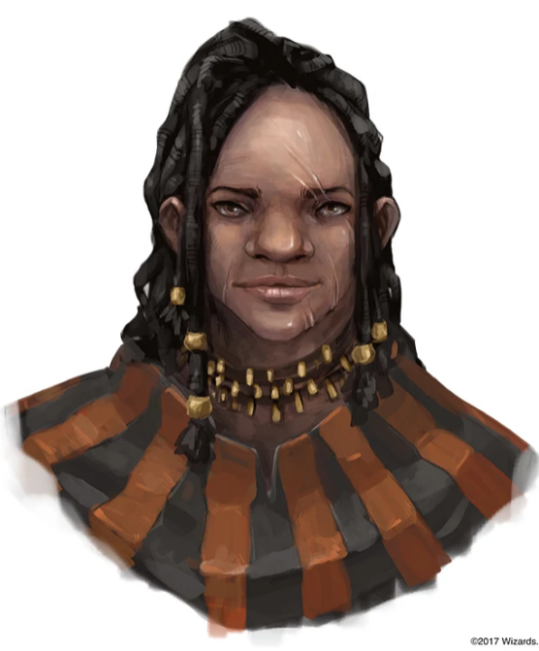
* Lunette tells her that we want to sell the Adamantine bars
  + Ekene-Afa tells us that the bars are stolen
  + She does not seem amused
  + We ended up making a deal to get Ghost a new Scimitar
* As we were walking away from Ekene-Afa, there was a dwarf that stopped us
  + 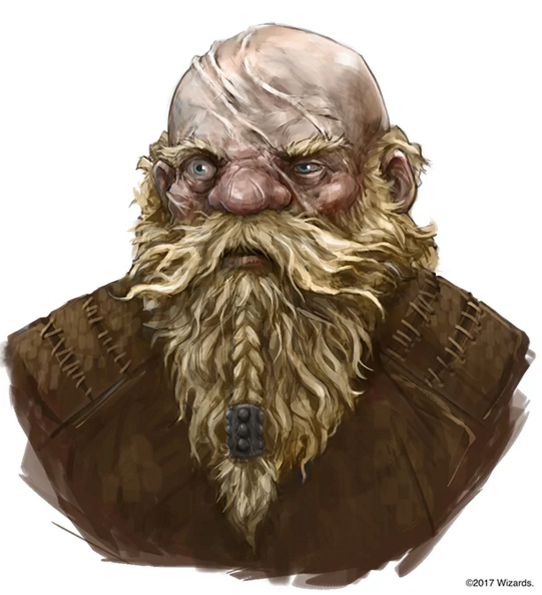
  + His name is Hew Hackinstone
  + He only has one arm
  + He has a dragon problem currently that we can go take care of
  + The party is talking about how this might be a little bit out of the way
  + We are going to take him along, but we are going to make a few stops on the way
* Lunette does some fortune telling to make 2 gp
* Ghost and Stella kick some major butt and each earn 200 gp
* I earned absolutely nothing

## Day 48

* There is a storm, so we aren’t going anywhere

## Day 49

* We are going to set off on this absolutely beautiful day
* Nneka isn’t here to teach me how to swim ☹
* It looks like we are going to look into getting a boat
* We decided to start walking instead of getting boats
* I decided to take the lead this time and it was a peaceful

## Day 50

* The weather today is a light rain
* I have decided to lead the party again today with a nat 20
* The day passes by without much issue
* At night, Lunette hears something in the bushes
  + She wakes Stella up and then they go to check it out
  + They just find a snek
  + They decide to keep watch for the rest of the night

## Day 51

* Today is light rain
* We tried to take a look and see if the snek trail leads anywhere
  + It doesn’t look like it does
* I lead the way to Mezro!
* In the evening, Lunette and I see a 10 ft. statue with vines
  + At the base there is a medal with a triceratops on it

# 9/30/2018

## Day 51 (cont.)

* I started to swim very very well once again
* We decided to take a rest for the night

## Day 52

* There is a torrential downpour today
* We walked around Mezro a bunch
* There were black fists here
  + I tried to break dance while swimming and wasn’t very stealthy about it
* Black Fists were here, saying we needed a charter to be exploring things
* We decided to stop exploring Mezro and move on with our lives
* We learn a little more about Ilanis and her ties with the Zentarhim
* There’s a bridge that we were able to cross after a maze
* Nothing else really happens today

## Day 53

* It’s just raining today
* We found a tower of some sort
* There’s a body on the ground
  + It’s kind of far away from the tower
* We start to climb the tower
* There’s a sexy spooder in a pit
* I was going to send Rémy into the pit to check it out but then Nneka jumped in and then Ghost jumped in and then I jumped in.
  + I wanted to kill it with fire

#### ~§~

### Battle

* Eku sighs and casts bless on me, Ghost and Nneka
* One of the spooders attacks me and misses
* Nneka spits poison at the spooder in front of her and hits for 10 points of poison damage
* Ghost throws a spear at one of the spooders and hits for a total of 4 damage. He then tried to boop another spooder and hits for a total of 8 points of damage
* The spooder tries to attack back but they miss
* Ilanis turns in to a dire wolf and jumps on the spooder closest to her. She kills it with 12 points of damage
* Stella, against her better judgement, jumps into the pit on top of the spooder and hits for 4 points of damage. She punches it for a total of 6 more damage
* A spooder tries to attack Nneka and misses and Ghost boops it for 6 points of damage.
* Lunette casts word of radiance. They each take 4 damage.
* Hugh is going to try to attack the spooder and misses
* I throw out my firebolt and hit for a total of 1 point of fire damage.
* Eku holds her action
* Nneka stabs the spooder for a total of 13 points of damage

#### ~§~

* I yelled at Nneka because I was worried about her
  + I feel really really bad about yelling at her. I know she can take care of herself, but it doesn’t mean I want something bad to happen to her. I’m still kinda mad at her, but only because I love her.
* There is a chute that Ilanis investigates
  + Ghost and Ilanis go up like Gods
* The rest of us follow
* There are Stirges in the room

#### ~§~

### Battle

* Stella hits one of the Stirge for a total of 8 damage
* Lunette casts word of radiance and kills 5 of them with a total of 6 damage to each of them
* I used magic missile and killed one of them
* Ghost throws his spear at one of them and kills it. He swings with his sword and misses
* The last remaining Stirge attacks Ghost and hits for a total of 5 points of damage
* Nneka boops the last one on Ghosts face and kills it

#### ~§~

* Stella checks out a bag
  + It has some neat stuff in it but nothing fantastic
* We go up to about 240 feet
* There are 4 Pterafolk up here
* 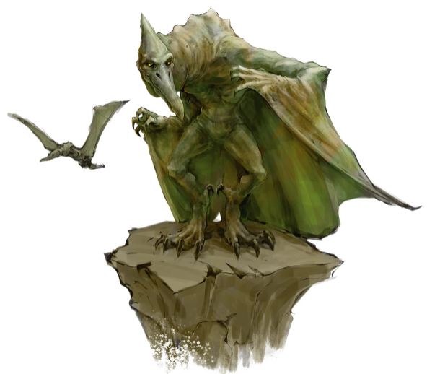
  + They are old
  + They are tending to a fire which makes this chamber very very hot
  + In here is also a bird person who here who seems to be tied up
* Ghost is absolutely insane and tries to use his breath weapon on the Pterafolk and hits them all for 5 damage
* I stay hidden and sent Rémy over to chew on the ropes that was holding the bird person

#### ~§~

### Battle

* Lunette casts sacred flame on one of them and does 8 points of damage, killing it
* Eku tries to boop one for
* Nneka stabs one of the Pterafolk for a total of 7 points of damage and kills it
* Ghost throws an ice knife at one of the Pterafolk. He hits for a total of 9 points of damage to 1.
* Stella goes over and scoops up the bird person and starts trying to help untie the bird person
* I shoot magic missiles over at the last Pterafolk and killed it with 11 points of damage

#### ~§~

* Nneka tries to loot the bodies but there isn’t anything of value on them
* The bird person is glad we came
* 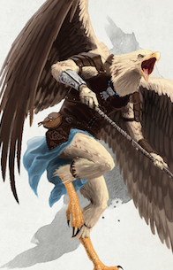
* The bird person yeets off of the tower
* We follow after them
* His name is Nephyr
  + He was out hunting and Nephyr was caught
  + As thanks he is going to help us get into Kir Sabal
  + We let him know we are going to escort him

# 10/7/2018

* 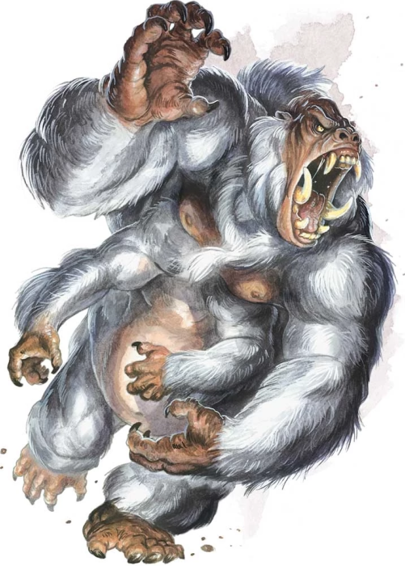
* We see these guys while trying to head to Kir Sabal
* Half of our party aren’t very sneaky
* These guys run away after half of our party falls
* Nothing happens at night

## Day 54

* The weather today is………………………. Heavy rain
* Nothing really happens in the morning
* There is something big coming that has footsteps that rattle the earth
  + It’s a couple of frost giants
  + They are looking for a ring
  + They say Artis has it
  + We let them know where we’ve seen Artis last
  + They let us go on our way
* Ghost isn’t thrilled that we gave the direction we saw Artis

## Day 55

* Torrential down
* We aren’t going anywhere

## Day 56

* It’s raining as lot
* I wanted to pay Eku but she won’t take my money any more
  + I am going to keep a tally of how much we owe her
* While we are walking, there are hooded folks in our path
* 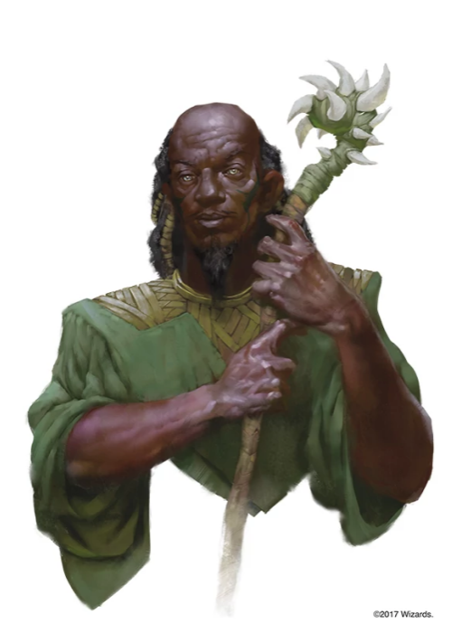
* 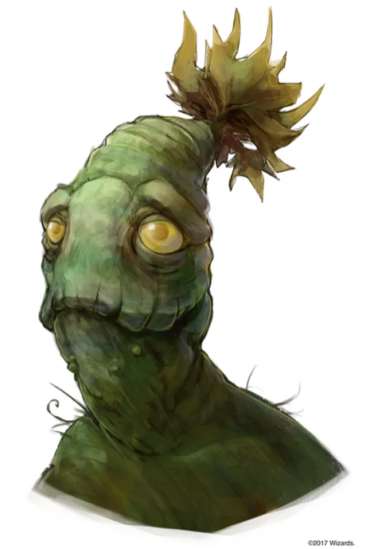
* They are wearing cloaks like what Stella is wearing
* Their names are Qawasha, Kupalue and Soleil
* They are part of the emerald enclave
* We exchange information with these people
  + They tell us about Omu and kind of gives us information we already knew
* They tells us about someone named _ and they think he is the one causing the curse
* It seems like the curse is spreading in the form of a circle
* Soleil and Lunette are going to try to stay in touch with each other via the raven Queen

## Day 57

* Torrential downpour
* We aren’t going anywhere

## Day 58

* Drizzling today
* There is an ancient monastery here
* We are going to climb this tower thing to get to where the bird people are
* After a couple of checks we were able to climb up to where the rest of the bird people are
* It’s very serene here
* We start to find some information on Omu
  + They have two people who are from Omu
  + There is a human child here named Na and an older person named Mwaxanare (Nare for short)
  + 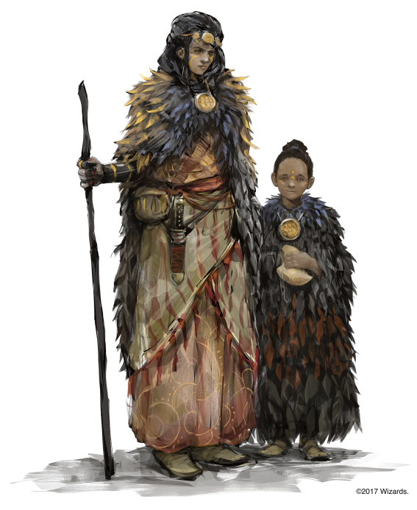
* We talk about trying to get the blood of the one of the children
* They were actually listening in on our conversation
* Me and the Nare are going to fight
* Everyone spends the afternoon just kind of hanging out
* Nare speaks to Nneka telepathically and tells her to come to her chambers
  + Nneka goes
* Nneka goes through with the transaction

## Day 59

* It’s a beautiful day
* I try to practice my swimming by myself
* At breakfast, Nneka talks about her business from the previous night
* I storm off to my room and Nneka follows
* I sneak out without Nneka hearing me and try to find a way to make money
  + I find Nare’s secret stash of stuff but get caught before I can take anything
  + I don’t do a very good job of lying
* Nneka realizes I snuck out of my room
* After a while I find Nephyr
  + We talk about how he’s in love with Nare
  + I tell him he should try to get together with her
  + He doesn’t seem to think she would be into him
  + I think he and her would get along just fine
* Nneka finds me talking with Nephyr and says she wants to talk to me
  + I’m nervous to talk to her, so I tell her I want to help Nephyr first and then we can talk
* We walk back to the breakfast table to talk to the other people there
* Stella grabs me and tells Nneka to follow and then she takes me into my room with Nneka so that we can talk
  + Nneka and I take and come to an understanding
  + I told her I would prover to her that I was serious about proving to her that I love her
  + She lets me know that there is a chance for us
  + I told her that I was sorry for being jealous
* In the afternoon, we see a bunch of the flaming fists
  + We try to sneak to not be seen, but we weren’t successful
  + They try to stop us, but we just run away after Lunette
* The night is uneventful

## Day 60

* Light rain today
* We make it to Nangalore
* 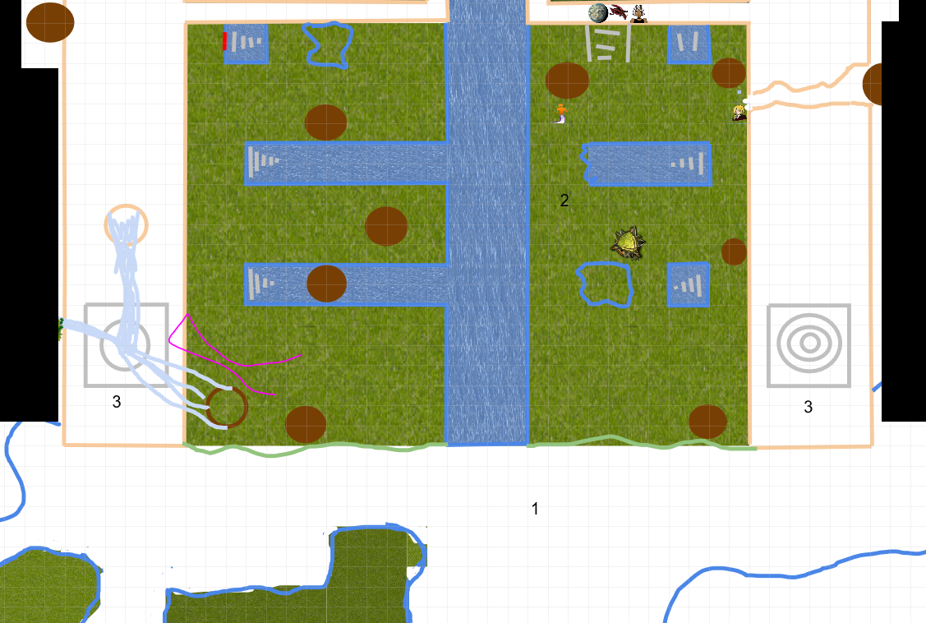
* 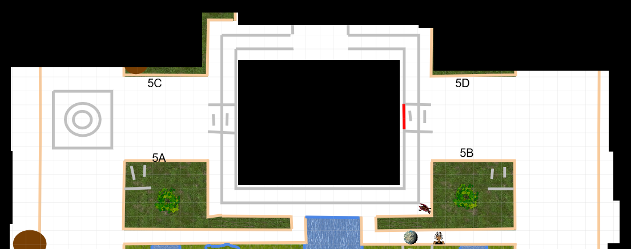

# 10/14/2018

## Day 60 (cont.)

* I did a swim

## Day 61

* I have no idea what happened here

## Day 62

* It is absolutely beautiful today
* We helped Nephyer with Nare
* A whole new world

## Day 63

* There is light rain today
* We did the ritual to fly
* We decided to make our way to the Heart of Ubtao
* At night time, our Red Wizard friends are back
  + They’re lost again
  + What losers
* We are going to work together

## Day 64

* It is downpouring
* I made a secret handshake with Neera
* Eldin is a dragon

## Day 65

* The weather today is pouring again
* We make it to the heart of Ubtao
* We give Valindra what she needs and she starts to ask the scrying spell
* We see
  + All of Chult
  + Zooms in to the peaks of flame
  + Goes between the peaks of flame and the valley of lost honor
  + There are parts of jungle
  + There are colorful birds
  + There is a waterfall
  + There is a ruined palace
  + It is very ancient

# 10/19/2018

## Day 65 (Cont.)

* We decided to spend the night at Valindra’s so that we can be well rested for the journey to Omu
* As everyone else was sleeping, I snuck over to Valindra’s magic stuff and started to mess around with it
  + While I was experimenting and trying to learn more things, something went wrong and I kind of opened a portal to a different dimension sort of thing
  + Nneka and Stella heard me messing around and came to check it out and got sucked into the portal
  + Eku also heard and for some reason thought of Marcie at the tavern we normally stay at before the portal closed, and they were all gone

## A strange situation

* Stella and Nneka find themselves in the middle of the tavern we normally stay at where they find a just as confused Marcie
* Marcie was especially confused because she saw so many people she knew all acting strangely
  + These people include:
    - Syndra
    - Elden & Neera
    - Hew & Deekin
    - Artis & Dragonbate
      * They’re married
    - Jaheira
    - Xhandalla
* Nneka takes advantage of the fact that they’re in Port and does a little bit of shopping
* Marcie tries to talk to some of her friends, but they don’t seem to recognize her
  + They learn that there is a carnival that is going to be in town and that it’s carrying a sickness with it
  + Marcie thinks it’s the death curse that they’re talking about, but it’s not
  + They talk to Syndra and find out that she wants to figure out the cause of the curse and is willing to pay the group to investigate
  + The group accepts the task
* As soon as they were ready to move onto the carnival, there were people who burst into the room to advertise it
* They go to the carnival where there is a lot to do, such as performances, dancing rats, a fortune teller, some carnival games, etc…
  + First, they decide to check out the dancing rats
    - Nneka loves it
  + They then decide to play some carnival games
    - Everyone wins a prize after pay a fair chunk for them
  + They have a run in with some fools that look like Lenny
  + After that they decide to check out the fortune teller
    - They’re not impressed
* After the fortune teller, the fools come back and try to take something precious from Marcie
  + She is not having any of that
  + They get ready to start a fight but Nare stops them
  + Nare apologizes and offers the group to take a break in her tent
  + She gives them more information about the carnival
    - They find out that it’s being run by Doctor Wakanga
    - The fools seem to keep to themselves and hang out in the maze of mirrors
    - No one really asks questions around here
* The group determine whether they want to go talk to Wakanga or if they want to check out the maze
  + They decide to head towards the maze and investigate that
  + On their way, they see Syndra sitting lumped over leaning against one of the tents
    - She’s babbling incoherently
    - Marcie puts her hands on Syndra’s shoulders to try and snap her out of it and gets stunned with madness for a few minutes
    - Suddenly, a fight breaks out as some of the fools come and attack with a bunch of rats

#### ~§~

### Battle

* Nneka is able to convince the rats to not fight with them since she can speak with animals
* Things start heading in a poor direction, but the battle ends in a victory

#### ~§~

* After the battle, the group makes their way to the maze of mirrors
* They go in and get lost for a little bit, some going slightly mad
* Finally, they find themselves in a grand room
  + 
  + There is a six-fingered hand that Nneka and Stella figure out is a symbol for Graz’zt
  + There are also runes in the room which Marcie recognizes as a ritual to make copies of people
  + In the middle is all of the people from the tavern as well as Wakanga
* Nneka and Stella attempt to break some of the mirrors and start to go a little mad as they do it
* Marcie looks around the room and sees Wakanga standing there watching them
* Marcie calls him out and he walks out, revealing that he’s not actually Wakanga, but Valindra
* They start a fight

#### ~§~

### Battle

* Valindra proves to be a worthy foe, changing her appearance to look like Marcie
  + This drives Marcie completely crazy and she thinks she’s someone else
* Nneka pretty much incapacitates Valindra until she’s useless by blinding her.
* The group is able to win the fight

#### ~§~

* Nneka finds a pipe of the sewers on Valindra as well as some money and a healing potion
* They’re still stuck trying to figure out how to make it out of the world when they finally hear me calling out the them
* Looking around, they find me tapping on a mirror and opening a way for them to get home
* They walk through the portal and make it back to where they were right before this whole crazy thing happened

## Back in the real world

* Stella and Nneka yell at me
  + I have a feeling I’m in a lot of trouble
* Valindra does that scary thing again
  + I’m definitely in trouble again
* I go to bed

# 10/28/2018

## Day 66

* It’s a rainy morning
* We decide we’re still going to help Hew
* Valindra and friends snap and disappear
* Eku helps us go down and head in the direction of helping Hew
* While we’re cruising, I see a small sack
  + I found two hooded lamps and 10 things of oil
* As we are going on, there is an undead dinosaur that attacks us

#### ~§~

### Battle

* Hew yeets over to the dino and boops him for 25 points of damage
* Eku blesses me, Ghost and Hew
* Lunette casts blindness on the dino. It does not work
* The Dino spits out a zombie and then attacks Hew. He hits for a total of 40 points of damage
* I cast scorching ray and threw them all at the dino. They all hit, one of them as a crit, and does a total of 23 points of fire damage
* Ilanis turns into a wolf and attacks the dino. She does a total of 9 points of damage
* Ghost casts chill touch on the dino and hits for a total of 10 points of necrotic damage. He then action surges and makes a couple more attacks. He hits all of them for a total 19 points of damage.
* The zombie goes over to Hew and tries to attack but misses horribly
* Hew was not amused so he’s going to boop the zombie. He’s going to deal 20 points of damage.
* Eku walks over and boops the dino for 7 points of damage
* Lunette casts guiding bolt and does a total of 9 points of damage.
* The Dino spits out another (well dressed) zombie. It then tries to bite Ghost and does 32 points of damage. He noms up Ghost and has him in his mouth. Finally, the Dino attacks Hew because he’s by his butt. He hits and does 25 points of damage.
* I send an even stronger scorching ray at the dinosaur and hit all 4 of them, one of them being a crit for a total of 31 points of fire damage.
* Ilanis munches on the dino again and does a total of 10 points of damage
* Ghost uses his breath weapon and freezes the dino’s head and shatters it, killing the dino. As the dino dies, 4 zombies claw their way out of the dino.
* One of the zombies attacked Lunette and did a total of 3 points of damage.
* Another Zombie tries to run and attack me, but Ghost boops him for 10 points of damage. The Zombie can’t move.
* A zombie tries to attack Eku and misses
* Another zombie tries to attack Hew and misses
* Hew goes to attack one of the zombies and crits for a total of 25 damage against the zombie.
* Eku tries to attack a zombie and hits for a total of 7 damage
* Lunette casts mass healing word on everyone who has taken damage. She heals them for a total 11 damage. She then literally destroys three of the remaining 5 zombies
* Nneka stops T-posing and joins the battle. She slithers on over to one of the zombies and does a total of 15 points of damage to the zombie, killing it
* I use another scorching ray and hit for a total of 17 points of fire damage
* Ilanis attacks the last zombie with a spork in her mouth. She hits for a total of 10 points of damage. It almost dies but doesn’t
* Ghost throws his spear and kills the zombie

#### ~§~

* Nothing else really exciting happens today

## Day 67

* It is a downpour today
* Lunette finds a crate
  + Inside are 20 sets of rations
* Nothing happens at night

## Day 68

* Light rain today
* We are moving at a fast pace again
* As we’re moving, Nneka gets grappled by vines
  + She takes 10 points of bludgeoning damage
  + I tried to throw a firebolt at it and do about 3 points of fire damage
  + Ghost looks around to see that it is a single vine. He uses frost bite and does 6 points of cold damage to the vine

#### ~§~

### Battle

* Eku goes and smacks the Vine in a smaller part of itself
* Ghost pulls out his scimitars and starts attempting to hack down the vines. He does a total of 19 points of damage.
* Hew attempts to attack some of the smaller vines and misses both of them because he’s short
* Nneka tries to figure out if the vine can hold more than one person and finds out it can only hold one, so she decides since she’s immune to poison she should just remain grappled.
* Ilanis maunches and does a total of 11 points of damage
* Lunette casts chill touch but it misses
* The plant sprouts more vines from the ground and Ilanis, Eku and Lunette are restrained
* I cast chromatic orb and hit with 15 points of lighting damage
* Eku is able to break free from the restraint
* Ghost turns on the weed whacker and does a total of 17 points of damage
* Hew says “time to mow the lawn” and hits for a total of 18 points of damage

#### ~§~

* I help Nneka up
* I send Rémy up onto Nneka’s shoulder and tell him to give her a lick on the cheek.
  + It literally kills him because of the poison that was on Nneka
* At night as we’re setting up camp, we come across a dead body
  + There is a GIANT charred constrictor snake and inside of the snake there is an Elf
  + On the Elf there is a malachite ring inlaid with electrum
    - I take it
  + I look around to see that there are snake tracks
    - It looks like the Elf and the snake were casualties
    - Whatever did this doesn’t seem to be around
  + I decide to keep watch just in case whatever did this decides to come back
* At night, Lunette seems to have a nightmare
  + There are a lot of Skeletons
* I check on Lunette when I hear Lunette moving around
  + As soon as I go and talk to her
  + There was a set of footprints next to Lunette’s bed
  + I try to use detect thoughts to see if whatever was there is still around
    - I could only detect the thoughts of my friends
  + Nneka and I spend the rest of the night with Lunette

## Day 69

* It is a beautiful day today
* On the way we find a tree with some fruit
  + We pick the fruit from the tree
  + I decided to eat one of the fruit
    - It tastes AMAZING but I feel the need to dance and then I’m poisoned
    - I do it again
* In the afternoon, we see a boat in the tree
  + It’s a treeboat
  + We take a look at it
  + Ilanis recognizes it as something from her homeland
  + We try to sneak up to it but I stubbed my toe
  + Someone calls out “Hallo” and asks if we can help him

# 11/4/2018

## Day 69 (cont.)

* So we start talking to the mysterious tree person
  + Her name is Thasselandra and she is the ship’s captain
  + She’s trying to talk but it seems to be hard for her
* We decided we are going to try and climb up to talk to her
* Stella yeets up the tree
* All of a sudden, there are 8 ghouls that appear surrounding us
  + I threw a fireball on top of us but also killed like 6 of the 8 of them
  + The other two ran away
* We all made our way up the tree and helped two drow that were on the ship
* We made them food and brought them over to the middle part of the ship
* We decide since the stern of the ship seems to be pretty unstable, we want to get everything to the middle of the ship
  + While I was trying to help and I started to fall out of the tree

#### ~§~

### Battle

* Stella cast radiant sun bolt and hit one of the monkeys for a total of 14 points of damage.
* Nneka casts Bane one two of the monkeys
* Eku casts Blass on me, the captain and Stella
* The monkey climbs up and Stella punches it for 10 points of damage. The monkey then punches her back for a total of 14 points of damage
* Lunette does some damage to one of the monkeys
* I cast Witch Bolt on one of the monkeys and crit it for a total of 4 points of damage
* One of the monkeys comes up and does some damage and the other monkey comes up but can’t do anything
* The captain does some damage to one of the monkeys
* Hew does some things
* The last monkey climbs up and punches Lunette a bunch for a total of 30 points of damage
* Stella punches the monkey for some damage
* Nneka sneak crits a monkey for 22 points of damage
* Ghost clips through the ground and does a total of 14 damage to one of the monkeys.
* Eku casts cure wounds on Lunette for a total of 15 points of healing
* One of the monkeys climbs onto the ship and punches and munches Stella, knocking her out
* Lunette casts healing word and heals Stella for 16 points of healing. She then tries to cast guiding bolt but it misses
* A monkey hops up onto the boat and munches me for 6 points of damage. He then turns and boops the captain for a total of 19 points of damage.
* The second monkey hops up and hits Ghost, me and Nneka
* Hew attacks one of the monkeys
* Stella tries to yeet one of the monkeys away but it doesn’t work
* Nneka does some things
* Ghost does a lot of damage
* There’s a monkey that does a lot of damage to Stella and takes her out again
* Lunette casts cure wounds at level 3 and heals Stella for a lot
* I yeet away from existance
* One of the monkeys yeets the captain off of the tree but Nneka is a super hero and casts feather fall on her
* The captain kills one of the monkeys
* Stella yeets one of the monkeys off of the tree boat
* Ghost kills another monkey
* I appear, kill a monkey, and then disappear again
* Nneka mocks a monkey to death. Literally
* After literally everyone tries to kill the last monkey, I send magic missiles and kill it for good

#### ~§~

* We finish setting everything up and then go to sleep

## Day 70

* It’s raining today

# 11/11/2018

## Day 70 (cont.)

* We goooooooooooooo

## Day 71

* BEAUTIFUL WEATHER WITH NOTHING GOING ON TO YEET OURSELVES TO OMU

## Day 72

* Downpouring today
* There’s a flock of flying snakes
  + Nneka casts animal friendship on them and now we have them as our friends

## Day 73

* Beautiful days are here to staaayyyy so to Omu we go

## Day 74

* I make another tally
* Stella has a strange dream
  + She dreams of chained figures
  + They are being dragged towards an alter that is covered in blood
  + Around this alter is a bunch of yuan-ti
  + Stella isn’t fazed by this

## Day 75

* Everything is as normal on another pretty day
* Stella nearly trips over a body
  + It’s a dead boi
  + There is nothing of value here

## Day 76

* It’s a torrential downpour today

## Day 77

* Today is light rain
* We haven’t make it to Omu yet
* Lunette has a crazy dream
  + She is able to shake it off

## Day 78

* There is a downpour
* Nneka asks me what my tallys for Eku are for
  + I tell her that it’s so that I can pay Eku
  + Nneka is able to sneak 11 gold into Eku’s pocket
* I tried to pick pocket Nneka’s clothes off
  + She catches me and asks me what I’m doing
  + I tell her what I was doing and ask her to teach me
  + She is able to flawlessly remove my clothes
  + Nneka is aroused
* We are able to yeet past 8 apes who are eating fruit
* We made it to Omu
* 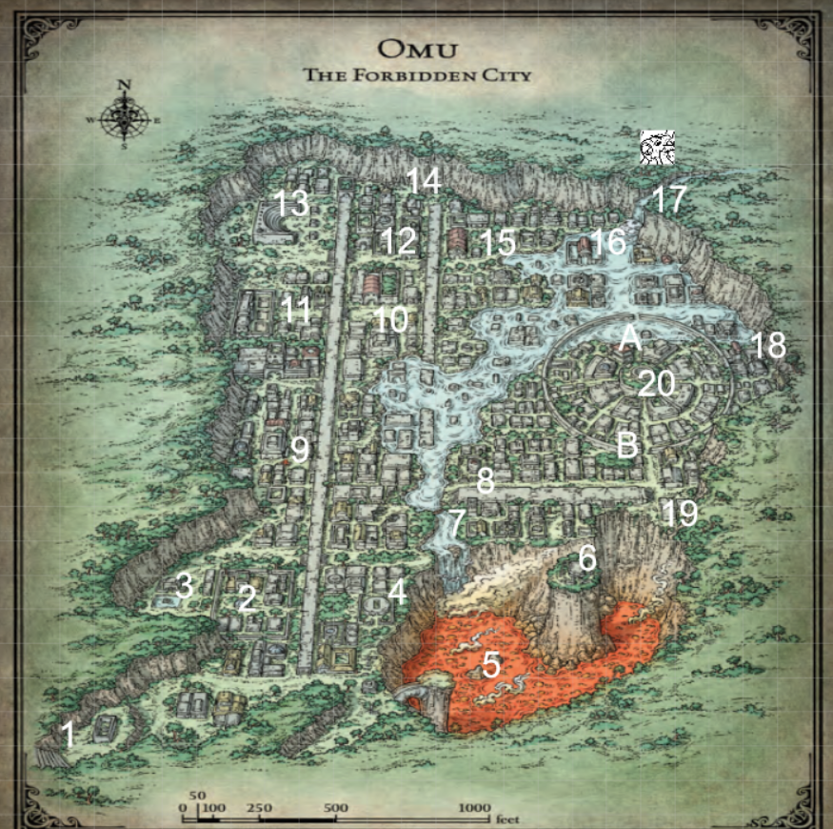
* We are going to jump off of the cliff and we start to yeet ourselves off of the cliff
  + Nneka had cast feather fall on all of us
  + There’s water at the bottom
    - For once in my life I can’t swim
    - Nneka saved me from the water
    - I did a bad thing
* We seem to have washed up to a temple
* “Papazotl teaches to bow before no one”
* We walk past the crocodiles like it’s nobody’s business
* After that there is a door that we are able to go through after reading something in old omuan
* 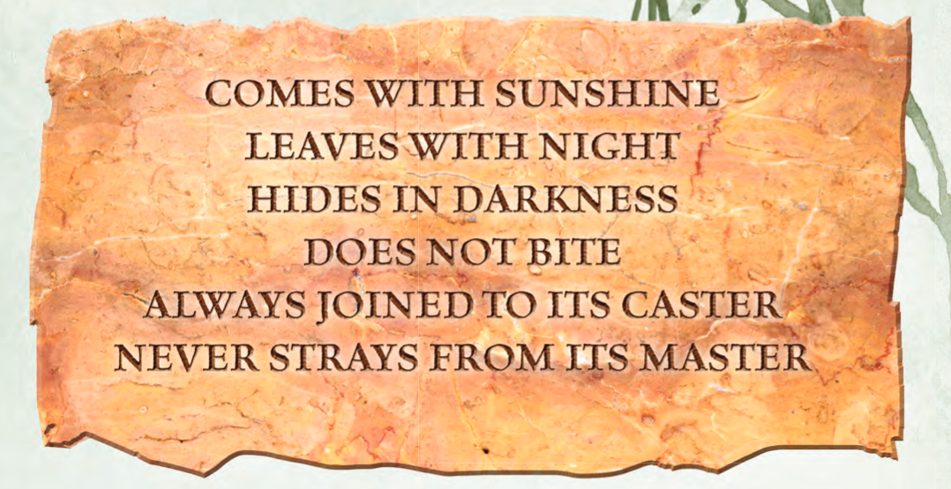
* Eku helps us out make us realize that we have to light up the bat statue
* There is a wall behind it
* When we go down the hall, we find a wall:
* 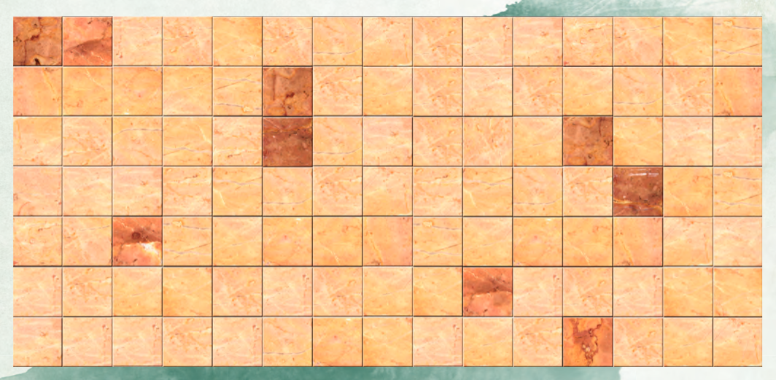
  + The dark spaces spell out “Cover Eyes”
  + I try to cover the eyes of the bat
  + Nneka covers the eyes of something else
  + Everyone soon covers the eyes of all of the statues
  + After we do all of that, there is a cube on a pedestal
* We leave the area and head somewhere else
* There wasn’t much in the place visited so we moved on
* We come across a place with an obelisk
* There is a door with a bunch of spaces where cubes can go
* Around the door there is a tunnel that has a bunch of the dudes except for the flail snail
* Beside the obelisk, the puzzle door and the tunnel there is not much here so we move on
* “Better to be Wongo’s friend than his enemy”
* Lion: "I ate one of the boar's friends" Blue light on right hand.
* Boar: "The vulture is lucky to be alive" Blue light on left foot.
* Zebra: "My only friend starved to death". Blue light on right foot
* Vulture: "One of the others has no friends". Blue light on left hand.
* Wongo’s friend knows where to put the water
* We put the water in the appropriate place

# 11/18/2018

## Day 78 (cont.)

* We start today with a battle

#### ~§~

### Battle

* Lunette summoned a flame blade and hits a monkey for 8 points of damage
* One of the monkeys and Lunette have a glare off
* Another monkey goes to attack Ghost and hits for a total of 10 points of damage
* Ghost attacks a monkey and does a total of 9 points of damage
* Eku blesses Me, Ghost and Stella. Yay
* Stella manages to get off a stunning strike on a monkey and hits it for 8 points of damage. She then hits for another 8 points of damage
* I cast fireball and manage to do 32 points of damage to two of the monkeys, killing them. I do 16 points of damage to the last one
* Lunette casts healing word on Ghost, healing him for a bunch of damage
* Ghost starts beating one of the monkeys, booping him for some damage
* Eku bonks the last monkey and kills him

#### ~§~

* I climb up the monkey and get the cube
* We decide to check out one more area before calling it a night
* There is something big here
* We go back to Wongo’s place
* I stay awake to try and find out if the bad dreams are coming from anywhere
* Ghost has a bad dream
  + I see this and wake Ghost up
  + We try to figure out if we recognize what any of it means, but can’t discern much
  + Maybe Aserack
  + I wasn’t able to sense anyone but my friends

## Day 79

* We find another puzzle area
* There is a floor with a bunch of different symbols
* 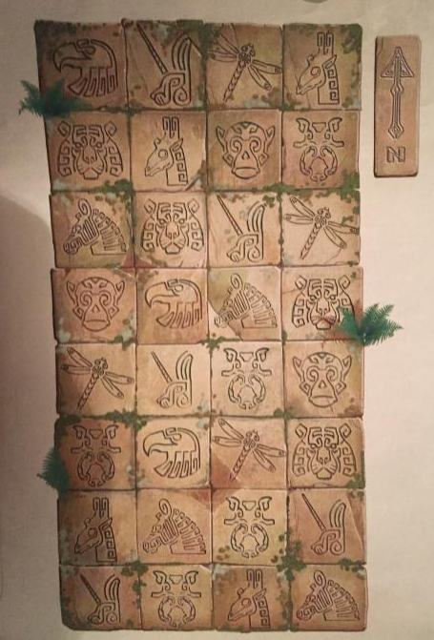
* We figure it out after a while
* There is a maze that I’m somehow able to solve flawlessly
* We get the cube thing and get out of there
* We start to explore a different area
* There was a cart that was in the middle of the street
* I have a Chwinga in my hair now
* As we are here, there are Red Wizard that seem to find us
  + They seem to know we are going to be here
  + One of their names is Zagmira
  + Valindra is here ☹
  + They have a cube with them
  + They ask if we found anything and Lunette and I try to tell them we haven’t
    - They call our bluff
  + Everyone tells them everything
* We move on, finding an abandoned camp site
  + There is a letter here that I was able to find
  + 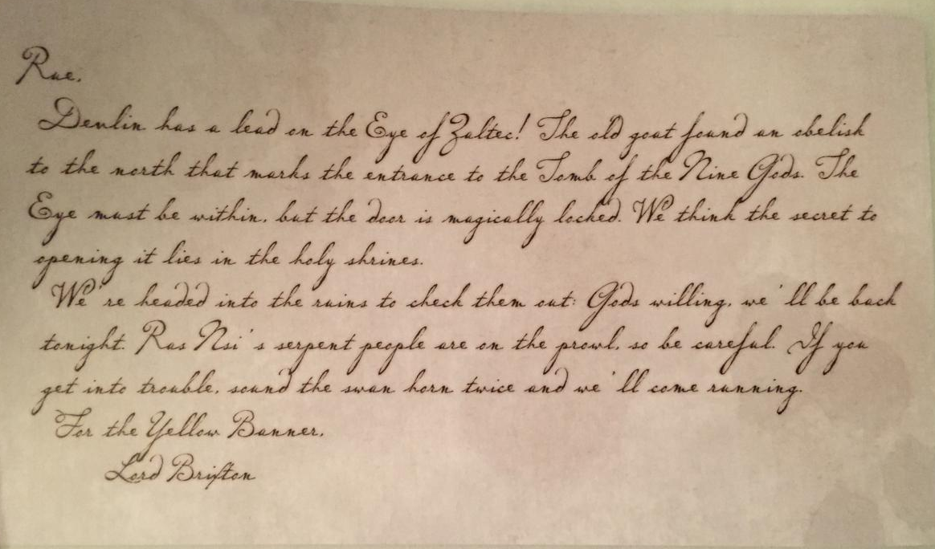
* We move on from this area and make our way to a watery place
* There’s a gate that I start to investigate as Ghost throws a rock into the water
* There an ugly frog looking thing
  + 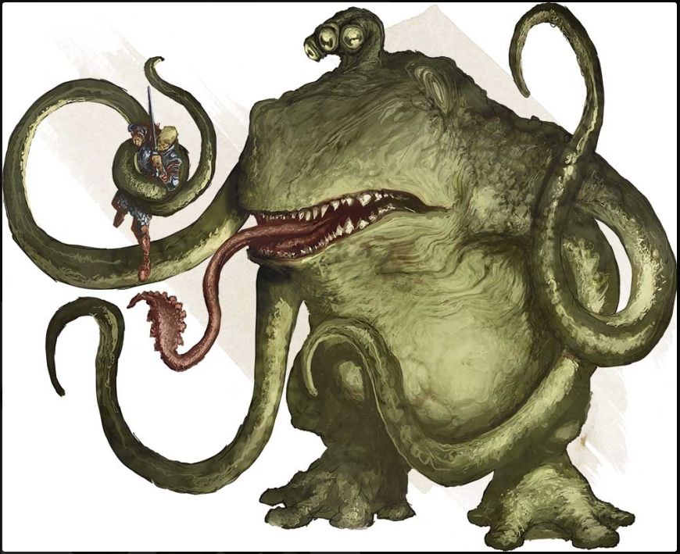
  + I nope right the heck on out of that place

#### ~§~

### Battle

* Stella boops the ugly frog thing with its staff and does a little bit of damage
* The ugly frog thing grabs both Ghost and Stella with its tentacles
* Eku gives Bless to Ghost, Stella and Lunette
* Ghost is able to break free from the ugly frog’s grasp and heals himself. He then does an action serge to try and cut Stella free, but he isn’t successful, but he does do some damage
* Lunette casts blindness on the ugly frog but is unsuccessful
* I step out from around the corner and cast Chromatic Orb and hit with a crit for a total of 22 points of lightening damage
* Stella tries to break free but is unable to
* The frog chomps down on Stella and does 34 points of piercing damage and then swallows her
* Eku turns into a spooder and goes into the ugly frog and bites down on it, doing a bit of damage
* Ghost goes ham on its stomach to try and get Stella and now Eku out of it. He isn’t able to do it, but he does some damage
* Lunette does a bit of damage to the ugly frog
* I cast Chromatic orb at level three and do 30 points of lightening damage
* Stella is passed out in the ugly frog’s, but she makes an amazing death saving throw and brings herself back with 1 hp
* The frog tries to attack Ghost but fails due to Ghost casting shield
* Eku yeets herself and Stella out of the frog
* Ghost continues to try and chop the frog up
* Lunette casts sacred flame on the Frog but it succeeds. She then casts healing work on Stella and heals her for 14 points of healing
* I cast Chromatic Orb again, this time just at first level. I think the real merit for me here is to keep damaging it with lightening
* Stella casts radiant sun bolt and does some damage
* The ugly frog grabs Ghost
* Eku is going to Yeet onto the frog’s head and tries to do some damage but misses
* Ghost tries to break free but is not successful
* Lunette casts sacred flame again and the frog saves from it successfully again. She then uses her channel divinity to heal Ghost and Stella
* I use another Chromatic Orb at level two and do 17 points of zappy damage
* Stella does another radiant sun bolt and hits, doing some damage
* The ugly tried to chomp on Ghost but couldn’t find his mouth
* Eku hurts the frog somehow and does dome damage. Like, 20 points of it
* Ghost tried to attack but boops his own snoot
* Lunette casts sacred flame and hits the frog
* I cast Chromatic Orb and miss horribly and hit Eku instead for 19 points of damage
* Stella is able to kill the ugly. She yeets herself onto the eye and kicks it back into the water

#### ~§~

* Nothing else of value happens with ugly the frog dies
* We go into the room where the puzzle cube is
* Ghost makes is way over to the cube and tried to take it
  + When he takes the cube and then the room starts to fill with poison
  + When Ghost puts it back there, everything stopped
  + Ghost swaps the cube for his sword and nothing happens
  + Once we are all out of the room, Ghost magically yoinks his sword back and the chamber starts to fill with gas
* As we leave the chamber, there are 9 Yuan-ti surrounding us

# 11/25/2018

#### ~§~

### Battle

* One of the Yuan-ti hits Nneka and she takes a total of 28 points of damage
  + Nneka doesn’t want the damage so she gets Pizza Rolls
* Another of the Yuan-ti tries to hit Stella, but Stella catches the projectile like a bad ass and throws it back, hitting them for 11 points of damage
* A third Yuan-ti hits Nneka for 6 points of damage
* A fourth Yuan-ti tries to hit Stella and hits for 3 points of damage
* Number five attacks Eku and hits, but Eku takes no damage
* Number six tries to CRIT Eku but also does no damage
* Seven hits me for a total of 11 points of damage
* Eight attacks Nneka and does 2 points of damage
* Nine attacks Eku and hits
* Nneka yeets away from the fight
* Stella does some things and ends with patient defense
* Eku is going to hit someone in front of her for 9 points of bludgeoning damage
* Lunette casts flame blade and boops the person in front of her for 8 points of damage
* Another of the Yuan-ti hits Illanis for a total 6 points of damage
* Illanis boops the person in front of her and knocks them down for a total of 11 points of damage
* Another Yuan-ti tries to attack Lunette but she has some awesome armor
* I cast fireball on half of the people and do 28 points of damage to those who failed and half as much to those who succeeded
* The Yuan-ti that Illanis jumped on tries to spray her with poison but it doesn’t work
* Another Yuan-ti tries to attack Eku but fails
* A third Yuan-ti attacks Lunette and hits for a total of 8 points of damage
* Another Yuan-ti attacks me and takes me down non-lethally
* Another Yuan-ti attacks Lunette and boops her for a bit of damage
* Nneka heals herself and then tosses a knife at the mf that took me down.
* Stella picks me up like a person and then kicks the things for some damage
* People do some things
* One of the Yuan-ti tries to convince Stella to take me and go with them
  + She’s like “No I don’t…”
* Lunette takes a lot of damage and goes down
* I’m going to bonus action break dance
* People have been doing things and I have not been paying attention. I am a terrible note taker tbh sorry friends
* There’s more things happening, ahhhhhhh I don’t know what’s happening because I’m knocked ouuuuttttt.
* We have all been healed for 15 points of healing. Lunette then casts Chill Touch
* Ilanis acts as a guard dog for one of the Yuan-ti
* I tell one of the leader type Yuan-ti to take his party and run. They don’t want to fight us
* The Yuan-ti who has Ilanis as a guard dog attacks Stella and does a little damage
* I did more of the spacing out thing oh man I suck
* Eku boops and Yuan-ti and takes it out
* Some things happen
* Eventually the battle is over

#### ~§~

* We start to move on
* There is a muffled voice that is calling for help under some rubble
* We move away the rubble to find something under the rubble
* Nira is here
  + Apparently, she was also attacked by sneak people
* There is a glaive here
* There is a Yuan-ti God Dendar
* Ghost has stopped T-posing
* We keep moving on to cross a giant tree bridge
* Something keeps shooting at us
  + I keep trying to hit them back
  + This guy’s name is Bag of Nails
  + 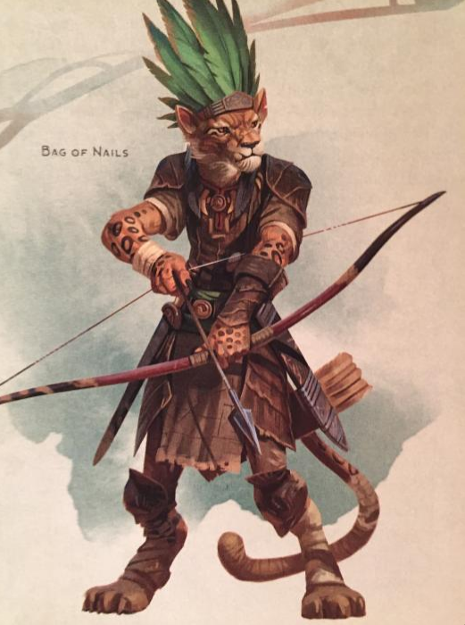
  + We leave this poor guy all alone
* We make our way to the shrine
* There is an extremely heavy door that Ghost and Stella are able to push open
* In here there is a pedestal with a flail snail
  + There are also a lot of keys
  + I was able to look into the keyhole and figure out the type of key that needed to be used to unlock things
  + Ghost forces me into a shed
    - Oh my
  + We are able to find the key that works to open the pedestal